HUMAN BIOLOGY – YEAR 12 CONTENT

SCIENTIFIC ENQUIRY

Observation – Information gained through your senses

Inferences- An explanation of an observation

Hypothesis- A positive statement based on an experiment that can be tested in an experiment.
“Exercise increases heart rate”

Independent Variable- A deliberately manipulated variable to test an effect.
Dependent Variable- The measured variable that forms the results of an experiment
Controlled Variable- Variables that must be kept constant

Controlling an Experiment- In order to ensure you only test the independent variable you must have controlled variables.

Experimental Group- Contains independent variable
Control Group- The exact same as the experimental group except it doesn’t contain and independent variable only a placebo.

Biological Variation- A mistake made in an experiment

Sample Size- The ice of one of the groups. Large sample size and repetition reduces the influence of biological variation, bias and experimental errors.

Random Selection- Random selection of groups reduces the influence of bias (the introduction of a variable other than the independent variable.

Placebo- An inactive substance given to the controlled group to reduce the psychosomatic effect (the effect due to expectation)

Results- Results recorded at the time of an observation, on a table then a graph displayed logically to see the relationship between the independent and dependent variables.

Quantitative Data- Expressed in numbers and involved measurement
Eg. Individual A is 178cm and B is 274cm
Qualitative Data- Not expressed using measurement or numerical data
Eg. Individual A is taller than B

Repetition- Repeating the experiment, this increases reliability.
Replication- Having a large sample size, this increases reliability.

Conclusion- A statement of if the results support the hypothesis. Must be backed up with evidence
Validity- An experiment is said to be valid when it tests what it is supposed to test. Validity is increased by controlling variables.

Reliability- The extent to which an experiment gains the same results amongst multiple trials.

Ethics- A set of principles, morals or values observed by society. In order to withhold an ethical experiment it must be;
- Voluntary participation
- Informed consensus (informed of risks and benefits)
- Confidentiality
- Risk of harm – should be non- existent.

THE ENDOCRINE SYSTEM

The endocrine system can be defined as a collection of endocrine glands that are involved in the regulation and coordination of the body through the production and release of hormones in the blood.

- The endocrine system and the nervous system are the two main control systems of the body
- The endocrine system in general is slower in speed of action but more persistent in length of action in comparison to the nervous system
- It is primarily involved in the control of; homeostasis, growth and reproduction.

There are two types of glands in the body;
Exocrine Glands: Secreted into a duct that carries the secretion to the body surfaces or to one of the body cavity’s.
- Sweat Glands, Mucous Glands, Salivary Glands and the Glands of the Alimentary Canal.
Endocrine Glands: Secretes hormones into the extra-cellular fluid that surrounds the cell that make up the gland. The secretion then usually passes into the capillary’s to be transported by the blood. Known as a ductless gland.
- Pituitary, Thyroid, Pancreas.

Exocrine | Endocrine
Releases secretions through ducts | Ductless Gland
Secretions act near the site of release | Hormones may act far from the site of release
Secretions released outside internal environment | Secrete hormones directly into the blood
Examples: Sweat Galnds, Salivary Glands, Alimentary Canal Glands | Examples: Pituitary, Ovaries, Testis, Thyroid, Pancreas

Hormones-

Chemical substances secreted by an endocrine gland into the blood which bind to complimentary receptor on/in target cells changing the activity of the cell.

- Hormones are chemical substances that are secreted by specialised cells in the endocrine glands
- Hormones circulate in the blood stream and bind to receptor molecules on/in a target cells, changing the activity of that cell.
- Hormones are specific meaning they are able to influence cells that have the correct receptor for that hormone
- If all receptor molecules are occupied, saturation occurs. In that case the addition of more hormone will not produce the greater effect.

Hormones at Work-

Protein and Amine Hormones: They work by attaching to receptor molecules on the cell membrane of a target cell. The combination of the hormone with the receptor causes a secondary messenger substance to diffuse through the cell and activate a particular enzyme.
Steroid Hormones: They work by entering the target cell (passing through the cell membrane and combining with a receptor protein inside the cell. The receptor may be on the mitochondria or on and other organelle.

How Hormones Change Activity of Cells-

Hormones change the functioning of cells by changing the quantity, type or activities of proteins (including enzymes).

Hormones may;
- Activate certain genes in the nucleus so that a particular enzyme or structural enzyme of protein.
- Change the shape or structure of an enzyme so that it is turned off or on.
- Change in rate of production of an enzyme or structural protein.

Enzyme Amplification- One hormone molecule can activate thousands of enzyme molecules. This is achieved through a process called enzyme amplification.

Feedback Control- Levels of a particular hormone in the blood may influence the release of a similar or in some cases different hormone (this is termed feedback). There are two types;
Positive Feedback: Feedback that reinforces the original stimulus.
Negative Feedback: Feedback that brings about a change opposite to, or reduces the effect of an individual stimulus.

Hypothalamus and Pituitary Gland

- Hypothalamus is located at the base of the brain. It plays an major role in the control of the endocrine system. It helps to regulate many basic functions of the body like body temperature and water balance.
- Many functions of the hypothalamus are carries out through the pituitary gland. The Pituitary Gland is located just behind the hypothalamus and is joined to it by a stalk called the infundibulum.
- The Pituitary Gland is not much bigger than a pea, about 13mm in diameter and is made up of anterior (front) and posterior (back) lobes.

Control Anterior and Posterior Pituitary

- The hypothalamus controls release of hormones from the anterior and posterior pituitary gland.

- This control is activated in different ways;
Anterior Pituitary: Is mainly controlled by releasing factors (hormonal control)
Posterior Pituitary: Is mainly controlled by nerve impulses (nervous control)

Anterior Pituitary-
- The anterior pituitary is controlled by releasing factors from the hypothalamus.
- These releasing factors travel from the hypothalamus to the anterior pituitary in the blood stream.
- The anterior pituitary gland is then stimulated to produce and release the corresponding hormone.

Example:
- FSH releasing factor is released from the hypothalamus.
- This travels in the blood stream to the anterior pituitary gland.
- The FSHRS (Follicle Stimulating Hormone Releasing Factor) then stimulated the anterior pituitary to release FSH.

Posterior Pituitary-
- Controlled by nervous stimulations from the hypothalamus
- Hormones are produced in the hypothalamus and travel down the special nerve cells (their extensions) the posterior pituitary where they are stored, ready for release into the blood stream.

Example
Nervous stimulation from the hypothalamus activated the release of the oxytocin from the posterior pituitary gland.

Comparison of Anterior and Posterior Pituitary
Pituitary | Where is the hormone produced? | Where is the hormone released? | How the hypothalamus controls the release? | Examples of Hormones
Posterior | Hypothalamus | Posterior Pituitary | Nerve impulses from the hypothalamus | Oxytocin
Anterior | Anterior Pituitary | Anterior Pituitary | Releasing and inhibiting factors from the hypothalamus | FSH  LH

Hormones Released by the Pituitary Gland

Anterior Pituitary Lobe
Hormone | Target Organ | Main Effects
FSH (Follicle Stimulating Hormone) | Ovaries (Females)  Testes (Male | Growth of follicles.  Production of sperm.
LH (Lutenising Hormone) | Ovaries  Testes | Ovulation and maintenance of the corpus luteum  Secretion of testosterone
GH (Growth Hormone) | All cells | Growth and Protein Synthesis
TSH (Thyroid Stimulating Hormone) | Thyroid Gland | Secretion of hormones from the thyroid, mainly thyroxin.
ACTH (Adrenocorticotropic Hormone) | Adrenal Cortex | Secretion of hormones from the adrenal cortex
PRL (Prolactin) | Mammary Glands | Milk Production

Posterior Pituitary Lobe
Hormone | Target organ | Main Effect
ADH (Anti-Diuretic Hormone) | Kidneys | Reabsorption of Water
OT (Oxytocin) | Uterus  Mammary Glands | Contraction of the uterus during child birth  Release of milk

Thyroid Gland-
- The thyroid gland is located in the neck.
- Consists of two lobes that lie on either side of the trachea
- Hormone secreted in thyroxin
- Increases metabolic rate
- Thyroid Stimulating Hormone secreted from the anterior pituitary gland controls the release of thyroxin.

Parathyroid Gland-
- There are four parathyroid glands, although some people have more
- Each is about the size of a pea embedded in the rear surface of the lobes of the thyroid gland.
- The parathyroid gland secretes the parathyroid hormone (PTH) which controls calcium and phosphate levels in the blood.

Thymus-
- The thymus is located in the chest, above the heart and behind the sternum.
- The thymus is largest in infants and children but begins to shrink after puberty.
- Thymus secretes a group of hormones called thymosins.
- These hormones influence the maturation of disease- fighting cells called T- lymphocytes.

Adrenal Glands-
- There are two adrenal glands located directly above each kidney.
- Each gland has an inner adrenal medulla and and outer adrenal cortex.
- These glands are very different in structure and function and each gland is really two separate glands.

Adrenal Medulla-
- Hormones produced are adrenaline and noradrenaline.
- Adrenaline also called epinephrine has an effect similar to the sympathetic division of the nervous system. Helps to prepare the body for fight or flight.
- Noradrenaline also called nor epinephrine has effects similar to those of adrenaline. In particular increase the rate and force of the heartbeat.

Adrenal Cortex-
- More than 20 different hormones are produced in the adrenal cortex and they are known collectively as corticosesteroids.
- The two main ones are;
Aldosterone: Acts on the kidney to reduce the amount of sodium and increase the amount of potassium in the urine
Cortisol: With which related hormones promotes normal metabolism, helping the body to withstand stress and it also helps with the repair of damaged tissues.

Pancreas-
- Lies below the stomach, alongside the duodenum (the first part of the small intestine)
- It is both an exocrine gland and an endocrine gland.
- The exocrine class secretes digestive enzymes into the small intestine through the pancreatic duct.
- Within the pancreas are special cells called the Isles of Langerhans. The islets are the endocrine part of the pancreas and they secrete two important hormones;
Insulin: This stimulates the uptake of glucose- lowers blood glucose level.
Glucagon: Stimulates the breakdown of glycogen and fast raising blood glucose level.

Gonads-
Gonads are testes and ovaries; they produce hormones as well as sperm and ova.
Hormones include;
Produces in the testes
Androgens: male sex hormones responsible for the development of the male sex characteristics (testosterone).

Produced in the Ovaries
Oestrogen: Stimulates the development of the female sex characteristics and regulates the menstrual cycle.
Progesterone: Regulates the menstrual cycle and pregnancy. Prepares mammary glands for milk secretion.

Control of Metabolic Rate
- Metabolism is the sum of chemical reactions occurring in the body.
- Basil metabolic rate is the sum of chemical reactions occurring when the body is at rest
- The rate of metabolism in the calls is controlled by the hormone thyroxin. Thyroxin is regulated by the action of the hypothalamus, anterior pituitary and the thyroid glands. Metabolic rate is controlled by the levels of thyroxin in the blood.

Hyperthyroidism
- Is a condition caused by higher levels of thyroxin due to an over active thyroid gland
- The problem is that even if not stimulated, the thyroid continues to make thyroxin.
- They would have low levels of TSH- Releasing Factor and high levels of thyroxin in the blood.
- Symptoms include:
- High energy
- Increased appetite
- Loss of weight
- Overactive
- Sleepless
- Bulging eyes

Hypothyroidism
- Is caused by lower than the normal level of thyroxin due to the thyroid not responding to stimulation (not producing enough thyroxin), even though the feedback mechanisms are working correctly.
- They would have high levels of TSH- Releasing Factor and TSH but low levels of thyroxin in the blood
- Symptoms include:
- Low energy
- Loss of appetite
- Weight gain
- Cold
- Feeling lethargic and tired

Comparison of nervous and endocrine system

Control of ovarian and menstrual cycle
- The menstrual cycle is the build-up and break down of the endometrium over 28 days it occurs in the uterus.
- The ovarian cycle is the development of a follicle, ova and corpus luteum it occurs in the ovary
- The ovaries produce hormones as well as ova
- Oestrogen, progesterone, FSH and LH- are the main hormones that are involved in the menstrual and ovarian cycles.
- The hypothalamus via hormones controls the menstrual and ovarian cycles.

Endocrine gland
Endocrine Glands  and Hormone | Function
Hypothalymus | Controls the cycle through the anterior pituitary by the release of releasing factors (FSH-rf and LH-rf)
Anterior Pituitary | Secreted FSH and LH
FSH | Develops ovarian follicle and stimulates follicle to secrete oestrogen
Oestrogen | Builds up the endometrium
LH | Causes ovulation
Corpus Luteum | Produces oestrogen and progesterone
Progesterone | Maintains the endometrium (in uterus) and makes it more vascular

Menstrual Cycle
- The hypothalamus (in response to low levels of oestrogen and progesterone) releases FSH
- The anterior pituitary releases FSH
- FSH causes a follicle to develop in the ovary and the follicle secretes oestrogen
- Higher levels of oestrogen start to build up the endometrium and causes the hypothalamus to secrete LH which causes the anterior pituitary to secrete LH.
- LH acts on the follicle causing it to burst producing an ovum and corpus luteum (ovulation)
- The corpus luteum continues to produce oestrogen and starts to make progesterone which maintains and makes a more vascular endometrium.
- Higher levels of oestrogen and progesterone from the corpus luteum are detected by the hypothalamus which reduces the release of FSH and LH which causes the anterior pituitary to stop producing FSH-rf and LH-rf (negative feedback)
Ovum Fertilised
- If the ovum is fertilised the corpus luteum is maintained and continues to produce oestrogen and progesterone
- This leads to the continued negative feedback on hypothalamus, therefore no more follicle development. The menstrual cycle and ovarian cycle ceases.
Ovum Not Fertilised
- If the ovum is not fertilised, after 7 days the corpus luteum breaks down.
- Lower levels of oestrogen and progesterone results in no negative feedback thus the hypothalamus (detects the low level of oestrogen and progesterone) and secretes FSH and a new cycle begins.
The Pill
- The pill contains high levels of hormones (oestrogen and progesterone)
- High levels of oestrogen and progesterone are detected by the hypothalamus and inhibits the release of FSH-rf and LH-rf (negative feedback).
- Anterior Pituitary therefore is inhibited from releasing FSH and LH.
- Therefore, no development of Graafian Follicle during the cycle (no ova released)
- Oestrogen and Progesterone in the pill release the hormones normally made by the follicle therefore the endometrium builds up and breaks down normally (menstrual cycle.

THE NERVOUS SYSTEM

Function of the Nervous System
- Responds to direct stimuli (changes in internal/external environment)
- Transmits nerve impulses from receptors to the brain
- Analyses sensory input from different receptors; stores information and integrates information
- Transmits nervous impulses form brain to muscles and glands to respond to stimuli

Neuron: 1 nerve cell.
Nerve Fibre: A long extension of the cytoplasm although the term is usually refered to as an axon.
Nerve: Bundle of nerve fibres held together by connective tissue.

Neurons
- A neuron or nerve cell is the anatomical and functional unit of the nervous system. It’s the only part of the body that conducts nerve impulses
Structure;
- The neuron has 3 district parts;
Cell Body: The cell body consists of a mass of neuroplasm surrounding the nucleus. The cell body contains the nucleus and directs activities of the rest of the cell. Axon and Dendrites extend from the cell body.

Dendrites: A branching structure. It carries nerve impulses towards the cell body, thus referred to as an afferent process.

Axon: The axon is typically long and less branching. It carries nerve impulses away from the cell body. Thus referred to as an efferent process.

Types of Neurons
Sensory (Receptor Neurons): Carry’s impulses from the receptor or sensory organs to the CNS.

Motor Neurons: Carry impulses from the CNS to an effector (eg. Muscles or glands).

Interneurons (association or connector neurons): Located in the CNS and provide a link between sensory and motor neurons.

Comparison of Types of Neurons
 | Structure | Function | Location
Inter | Central Cell Body.  Axons and Dendrites of equal length.  No myelin sheath present. | To join motor and sensory neurons, form the grey matter of the brain | Brain and Spinal Cord (CNS)
Sensory | Cell Body and Central.  1 Neuron.  Long dendrites, short axon.  Dendrite endings form receptors. | Transport impulses from the receptors to the CNS ie. afferent | PNS
Motor | Cell body close to dendrite  1 long axon, many short dendrites.  Axon joined onto effectors by motor end plate. | Transport impulses from the CNS to the effector  ie. efferent | PNS

Parts and functions of a neuron

Part | Function
Dendrites | Carry nerve impulses towards the cell body.
Axon | Carry’s nerve impulses away from the cell body.
Myelin Sheath | Fatty tissue that acts as an insulator, protects axon from damage, speeds up nervous impulses.
Schwann Cell | Protects the myelin sheath, involved in repair of fibres
Nodes of Ranvier | Gaps in myelin sheath
Neurilemma | Around the myelin sheath, helps to repair injured fibres
Motor end plate | Where the impulses are transferred to the effector
Synapse | Junction between neuron, slowest part of nervous transmission
Filament | Carry’s impulses to motor end plate.
Nucleus | Controls activities of neurons.

Synapse
- Junction between adjacent neurons is called a synapse.
- At the synapse the neurons do not actually join there, there is a very small gap between them
- Neurotransmitters (Acetylcholine) diffuse over the gap to continue a nerve impulse

Peripheral Nervous System (PNS)
- 12 pairs of cranial nerves associated with the brain
- 31 pairs of spinal nerves which leave the spinal cord

The PNS can be divided into 2 divisions
Afferent: Carry’s impulses towards the CNS
- Somatic sensory neurons from skin and muscles
- Visceral sensory neurons from internal organs

Efferent: Carry’s impulses away from the CNS
Somatic Nervous System; Concerned with detecting changes in the external environment (through sensory neurons) and then voluntary responds to these (through motor neurons) controlling skeletal muscle contraction

Autonomic Nervous System; Responsible for the bodies internal environment (through homeostatic mechanisms help keep the internal environment constant (homeostasis). Mainly involuntary.
- Sympathetic
- Parasympathetic

Comparison of Autonomic and Somatic Nervous System

Characteristic | Autonomic | Somatic
Effectors | Heart muscle, involuntary muscle gland | Skeletal Voluntary Muscles
General function | Adjustment of internal environment | Response to external environment
Efferent pathways | Two nerve fibres from the CNS to the effector with a synapse and a ganglion | One nerve fibre from the CNS to the effector. No synapse, no ganglion
Neurotransmitter at effector | Acetylcholine and Noradrenaline | Acetylcholine
Control | Involuntary | Voluntary
Nerves to target cell | Two sets; Sympathetic + Parasympathetic | One set

Sympathetic and Parasympathetic of PNS
The autonomic nervous system can be further divided into 2 divisions.
-Sympathetic
-Parasympathetic

The sympathetic division responds to prepare the body for greater physical activity. Also known as ‘fight or flight’ response

The parasympathetic responds to maintain the body of rest and relaxation. Also known as ‘rest and digest’.

Effects of the Autonomic Nervous System

Structure | Effect on sympathetic stimulation | Effect on parasympathetic stimulation
Heart | Increase rate and strength of contraction | Decreases the rate and strength of contraction
Lungs | Dilates bronchioles | Constricts bronchioles
Stomach, intestines | Decreases movement | Increases movement
Liver | Increases breakdown of glycogen and release of glucose | Increases uptake of glucose and the synthesis of glycogen
Iris of the eye | Dilates the pupil | Constricts the pupil
Sweat Glands | Increases sweat secretion | No effect
Salivary Glands | Decreases secretion of saliva | Increases secretion of saliva
Blood Vessels of Skin,  Skeletal Muscles,  Internal Organs | Constricts blood vessels  Dilates blood vessels  Constricts vessels | Little effect  No effect  Little Effect
Urinary Bladder | Relaxes muscle of wall | Constricts muscle of wall
Adrenal Medulla | Stimulates hormone secretion | No effect

Central Nervous System
- Made up of the brain and spinal cord
Protection;
The brain and spinal cord are very soft and delicate stuctures that need to be protected.
They are protected by:
- BONE: The bones of the skull enclose the brain (cranium). The spinal cord is enclosed in the spinal canal that is formed by vertebrae. This protects the CNS from knocks and bumps.
- JACKET OF FLUID (CEREBROSPINAL FLUID): The brain and spinal cord are surrounded by fluid called CSF. This acts as a shock absorber, it supplies nutrients and remove waste.
- MEMBRANCES CALLED MENINGES: The meninges are connective tissue that cover the inside of bones of the CNS. It produces the CSF and contains it.
They consist of 3 layers:
- Inner: Contains many blood vessels, sticks closely to brain and spinal fluid
-Middle: Thin but waterproof
Outer: A tough double layer sticking closely to the bone.

The Brain
- The brains role in the CNS is of a receiver, analyser, co-ordinator, storer and initiator of nerve impulses.
- The brain also has the unique function of memory

FUNCTION OF PARTS OF THE BRAIN
Medulla | Regulates heart rate, breathing and diameter of blood vessels.
Ponds | Co-ordinates and transmits information between cerebral cortex, cerebellum and spinal cord.
Pituitary Gland | Master gland, controls other endocrine glands by producing hormones.
Hypothalamus | Regulates basic body functions, mostly concerned with homeostasis.
Cerebral Cortex (Cerebrum) | Higher order functions such as thinking, reasoning, memory, learning, awareness of surroundings.
Corpus Callosum | Band of nerve fibres that lie underneath the cerebrum that connects the left and right hemispheres.
Cerebellum | Co-ordination of fine contractions of muscles, resulting in smooth movements and the maintenance of posture and balance.
Spinal Cord | Provides a pathway for communication between muscle glands and the brain. Integration of autonomic protective refluxes.
Thalamus | Acts as a relay station. All sensory information passes through the thalamus before going to the cerebral cortex.
Medulla Oblongata
- A continuation of the spinal cord.
- The medulla contains;
-Cardiac Centre: Regulates rate and force of heart beat.
-Respiratory Centre: Controls rate and depth of breathing.
-Vasomotor Centre: Regulates diameter of blood vessels.

Structure of the Cerebral Cortex (Cerebrum)
- Largest part of the brain.
- It consists of an outer layer of grey matter called the cerebral cortex
- The cerebral cortex is folded into patterns that greatly increase its surface area, in this way the cerebral cortex contains 70% of all neurons in the CNS.
- Founding produces round ridges called convolutions. the convolutions are separated by either shallow down folds called sulci or deep down folds called fissures.
- The longest deepest fissure is the longitudinal fissure that separates the brain into two hemispheres, the left and right cerebral hemispheres.

Lobes of the Cerebral Cortex

Functions of the Cerebral Cortex
- The cerebral cortex is involved in higher order functions such as; thinking, reasoning, learning, memory, intelligence and sense of responsibility.
- It is also concerned with perception of the senses and the initiation of control of voluntary muscle contraction.
- The cerebral cortex can be divided into three main functional areas;
- Sensory Areas: Interprets impulses from receptor
- Motor Areas: Controls muscular movements
- Association Areas: Interprets information from the senses to make it useful

Cerebral Cortex Functional Areas

Cerebellum
- Lies in the rear part of the brain.
- Second largest part of the brain.
- It has an outer layer of grey matter and an inner layer of white matter.
- The cerebellum has control over posture, balance, fine co-ordination of voluntary muscle movement.
- To carry out these functions the cerebellum receives information from the inner ear and from stretch receptors in the skeletal muscles.

The Hypothalamus
- It lies in the middle of the brain and cannot be seen from the outside
- Controls many body activities; mostly concerned with homeostasis; regulation of body temp, metabolism, thirst and response to fear and anger.
- The hypothalamus also has a role in co-ordination of parts of the endocrine system; acting through the pituitary gland; the hypothalamus regulates metabolism, growth, reproduction and response to stress.

Spinal Cord
- Function of the spinal cord is to carry sensory impulses to the brain and motor impulses away from the brain. Another function is to integrate certain reflexes.
- The spinal cord consists of ascending and descending tracts.

- Ascending Tracts: Sensory axons that carry impulses towards the brain
- Descending Tracts: Motor axons that conduct impulses away from the brain

Cross section of the spinal cord

Grey and White Matter
Grey Matter: Part of the brain and spinal cord that is made up of nerve cell bodies and unmyelinated fibres, it is located in the inside of the spinal cord and on the surface and outside of the brain.
White Matter: Part of the brain and spinal cord that is made up of myelinated fibres, myelin is white in colour so the tissue appears white, it is located on the outside of the spinal cord and towards the inside of the brain.

Comparison of Nervous and Endocrine

Receptors
A receptor is a structure that detects change in the internal and external environment.
Receptor | Detects | Location
Thermoreceptors | Temperature change | Skin detected change in an external environment.  Hypothalamus detects change in the internal environment.
Osmoreceptors | Osmotic pressure | Hypothalamus
Chemoreceptors | Chemical change eg. pH, Co2 and O2 | Internal
Touch receptors | Touch | Mainly Skin
Pain receptors | Pain/damage to tissue | Skin, most organs (not brain)

Reflexes
- A reflex is an autonomic response in the external and/or internal environment.
- Some reflexes involve the unconscious part of the brain; however, most are co-ordinated by the spinal cord.
- A spinal reflex does not involve the brain; the brain may become aware of what is happening but it does not become aware until after the response has been initiated.
- Reflexes have 4 important properties;
- A stimulus is required to trigger a reflex- it is not spontaneous
- A reflex is involuntary- it occurs without any conscious thought
- A reflex response is rapid- only a small number of neurons are involved
- A reflex is stereotyped- it occurs in the same way each time it occurs

Examples of Reflexes
- Many reflexes have a protective function
Examples | Stimulus | Response | Reason
Pupil | Bright light | Pupil constricts | Protects retina
Knee | Stretch of patella tendon | Knee jerks, straighten muscle | Maintains balance
Eye | Motion near eye | Blink | Protect from injury
Swallowing | Touch the uvula | Swallowing epiglottis closes the trachea | Prevents choking

Reflex Arc
- The pathway a nerve impulse follows in traveling from receptor to effector called a Reflex Arc. The basic elements of a reflex arc are;
- Receptor
- Sensory Neuron
- Connector Neuron
- Motor Neuron
- Effector

HOMEOSTASIS

The maintenance of a constant optimal internal environment irrespective of the external one.

- Humans can exist in a variety of environments eg. Deserts, tropic, artic
- However, in spite of this they maintain a constant internal environment at an optimal level.
- Without maintaining this constant optimal internal environment human cannot survive

Optimal: Conditions that are the best suited for the cells and therefore the organism.

Internal Environment: The fluid environment of the body, consisting of intercellular fluid, intracellular fluid, plasma and lymph.

Factors to be maintained
The human body must maintain a constant level of particular factors to survive:
- Body temperature
- Fluid levels
- Concentration of glucose in the blood
- Concentration of oxygen
- Concentration of carbon dioxide

Feedback Loops
The stimulus- response feedback model is a simple way of explaining how homeostasis mechanisms work.
- A feedback loop is a circular process which occurs in the body in response to change (stimulus) that needs to be corrected to maintain homeostasis. Feedback loops have a series of common features.
- Stimulus- the change in the internal environment that causes the system to operate
- Receptor- the structure which detects the change
- Modulator- control centre of the system which processes the information from the receptor and sends information to the effector
- Effector- the structure which brings about the response
- Response- change in the effector to maintain homeostasis
- Feedback- how response changes/modifies stimulus

Negative Feedback
The feedback that brings about a change opposite to, or reduces the effect of an original stimulus.
EXAMPLE:
- A good illustration of the process of negative feedback is a fridge that maintains constant temperature. The fridge is too cold.
Fridge Motor, Motor stops, too cold, warms up, control box, temp sensor.

Positive Feedback
- Positive feedback is when the response to a stimulus reinforces or intensifies the stimulus.
- Positive feedback does not result in homeostasis, but there are a few situations which it does occur.
EXAMPLE:
- Labour is initiated by secretions of oxytocin from Posterior Pituitary
- Oxytocin causes contractions of the uterus
- The contractions push the baby’s head against the cervix
- Stimulation of the cervix causes it to send nerve impulses to the brain, which responded by instructing the PP to secrete more oxytocin.
- These contractions push the baby’s head more forcibly against the cervix, which sends even more impulses to the brain, even more oxytocin is released and the contractions intensify.

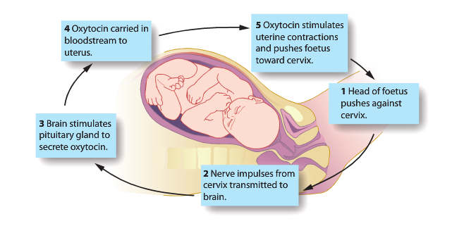

Temperature Regulation

Thermoregulation (regulation of temperature
- Homoeothermic/Endothermic organisms are able to maintain a relatively constant internal body temperature independent of the external temperature.
- The optimal temperature is 37 degrees.

Why is temperature homeostasis important?
A constant internal temperature is important because;
- Metabolic processes require optimal temperature
- At temperatures higher then 37 enzymes can denature and stop functioning
- At temperatures lower then 37 chemical reactions in the body slow (collision theory)

How much temperature variation is too much?
- A rise of only 2 degrees will make a human feverish and should temperature reach 43-45, death may occur.
- Our tolerance to lower temperature is much greater and temperatures need to fall below 23 to be fatal

Heat Loss vs Heat Gain
In order to maintain a constant body temperature, we must balance heat production/gain with heat loss
- If we are getting too cold, we must reduce heat loss whilst increasing heat production by increasing heat level of activity/metabolism.
- If we are getting too hot the reverse must occur- decrease production and increase heat loss.

Heat gain must be equal to heat loss….
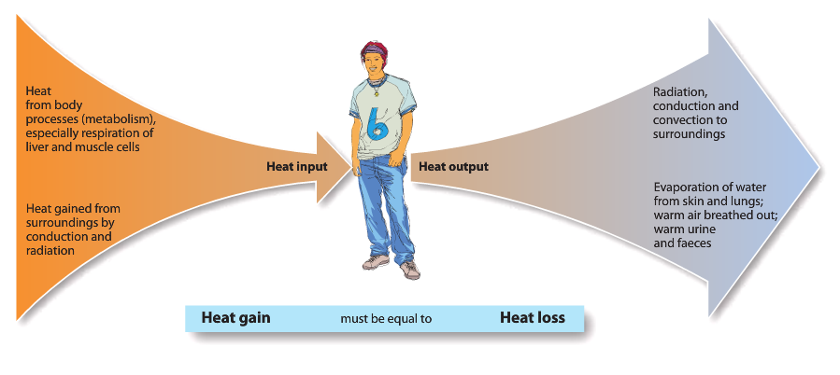

Behavioural and Physiological responses
In order to regulate heat, gain and heat loss humans respond in two ways

- Behavioural: Where we consciously change our behaviour.
- Physiological: where our body automatically alters its functioning without conscious control.

Heat production
- Carbohydrates, proteins and lipids that we eat contain energy in chemical bonds
- Through cellular respiration this energy is released as heat
- The rate at which energy is released by the breakdown of food is known as metabolic rate

Thermoreceptors
- The body has temperature receptors.
- Peripheral thermoreceptors are located in skin and mucous membranes.

- Cold receptors: detect a drop in internal body temperature
- Hot receptors: detect a rise in internal body temperature

- Central thermoreceptors are located in the hypothalamus

Mechanisms for regulation of body temperature

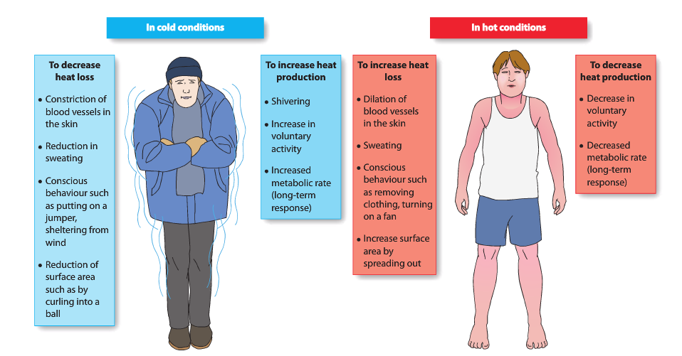

Temperature regulation
Receptors: thermoreceptors located in skin and hypothalamus
Modulator: hypothalamus
Effectors: skin, blood vessels, body cells, muscles and sweat glands

Negative feedback loop

Response to decrease in temperature of external environment
- Stimulus- low body temperature
- Receptor- Thermoreceptors in skin and hypothalamus detect low body temperature
- Modulator- Never impulses are sent to the modulator (hypothalamus). This is stimulated if the bodies core temperature is below 36 degrees.
- Effector- Body cells, muscles skin, blood vessels and cerebral cortex.
- Response- Increased metabolic rate, shivering, vasoconstriction of peripheral arterioles in the skin, change in behaviour.

Vasoconstriction on skin

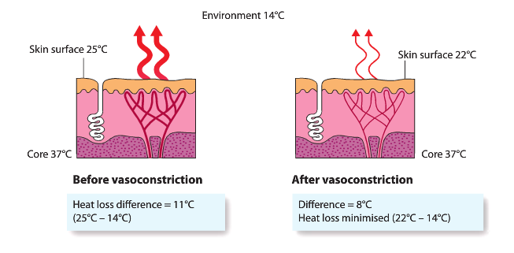

Cold Condition  Core Temperature below 36 degrees | Physiological  methods | Behavioural  methods
Need to increase heat gain | - Increased metabolic rate  - Shivering | - Deliberate increase in movement and exercise
Need to reduce heat loss | - Decreased sweating  - Vasoconstriction of peripheral arterioles in skin | - Increased insulation  - Turn on a heater  - Put on a jumper

Altering Metabolic Rate
- Longer term readjustment of heat production in response to seasonal variation can be made by the secretion of thyroxin from the thyroid.
- During autumn the ambient temperature starts to drop and the thyroid becomes more active
- When energy is relapsed from the breakdown of ATP 70% of the energy is lost as heat
- Adrenaline and noradrenaline also increase metabolic rate

Temperature regulation of high body temperature
If our core temperature rises beyond the termoneutral zone (above 38) the heat production is depressed and the heat loss centre is switched on.

Response to increase of temperature of external environment
- Stimulus- high body temperature
- Receptor- Thermoreceptors in the skin and hypothalamus detect high body temperature
- Modulator- Nerve impulse is sent to the modulator (hypothalamus). This is stimulated if the body’s core temperature rises above 38 degrees.
- Effector- body cells, sweat glands, peripheral arterioles and cerebral; cortex
- Response- Decreased metabolic rate, sweating, vasodilation of peripheral arterioles in the skin, change in behavior (take clothing off, decrease activity and sprawl out).
Section of skin showing sweat gland
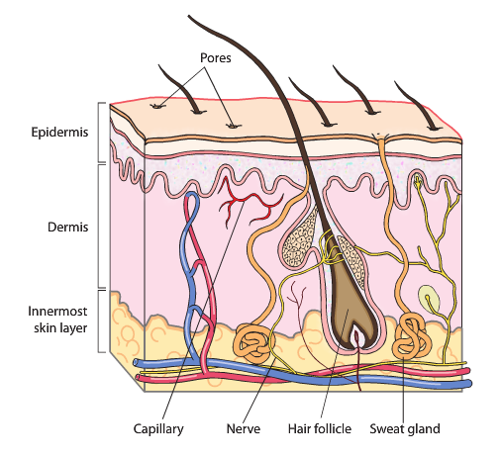

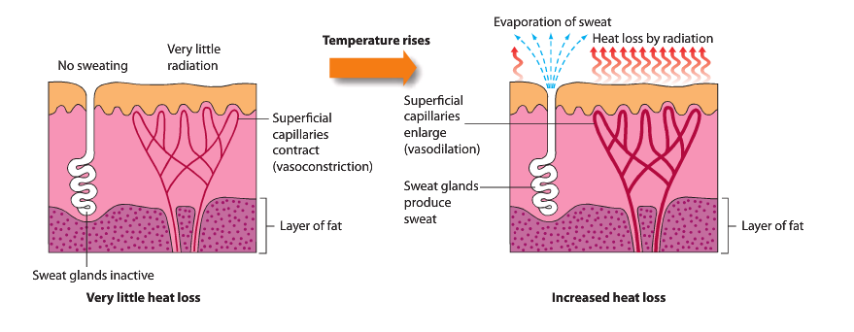
Heat loss from skin by increased vasodilation

Negative Feedback

Hot Conditions  Core Temperature  above 38 degrees | Physiological Methods | Behavioural Methods
Need to reduce heat gain | Reduce metabolic rate | Find somewhere cool
Need to increase heat loss | Vasodilation of peripheral arterioles in the skin and sweating | Find somewhere cool, go for a awim and remove clothing

Heat Transfer
Heat can be transferred in four ways;
- Convection
- Conduction
- Radiation
- Evaporation
Convection
- An object will heat ort cool the air as it passes over the object
- Warm air created by contract with a warm body rises and is replaced with cool air.
- The currents of moving air remove heat energy from the object
Conduction
- This type of heat transfer involves heat energy moving from a warmer object to a cooler object when they are in direct physical contact.
- If you touch a cold object heat passes from your body to the object.
- The reverse happens when you touch something hotter than your body.
Radiation
- Heat energy moves from a warmer object to a cooler object across space.
- No contact us necessary
- If your body has a higher temperature then the environment you will radiate heat into the environment, which cools the body and vice versa.
Evaporation
- This occurs when liquid water is converted into water vapor.
- This process requires energy which is taken from the body in the form of heat, thus cooling the body.
- As we sweat the evaporation of sweat from the skin cools the body.
Body Fluid

- The human body has approximately 60% water but varies between individuals. Most of this water is contained in body fluids.
Intracellular fluid: Fluid inside the cell or cytoplasm
Extracellular fluid: Fluid outside the cell
- Intercellular fluid: fluid between the cells (excluding blood plasma). Altermatively known as interstitial fluid and tissue fluid.
- Plasma is the fluid in a blood vessel.
Body fluids
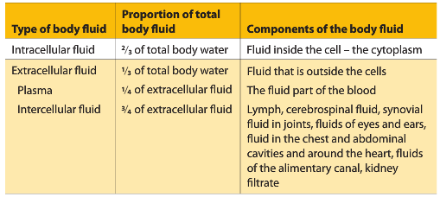

Regulation of body fluids
Regulation of the composition of body fluids is need to maintain optimal conditions for cells therefore efficient functioning of cells. The five components that need to be maintained are;
- Ph
- Nutrients
- Metabolic wastes
- Dissolved gasses
- Water levels
Metabolic Wastes
- Metabolic wastes are products of metabolism that are no more use to the body. These wastes need to be excreted, as some of them may be harmful if they are allowed to build up in the body. The removal of metabolic wastes from the body is called excretion.
- The removal of a substance that was not involved in the body’s metabolism is termed elimination. (Passing of fasces is elimination).
Excretion
- The lungs are involved with the excretion of carbon dioxide. Some water vapor, as we exhale.
- Sweat glands in the skin secrete sweat, which is largely water, for cooling. Sweat contains by-products of metabolism such as water, salts, urea and lactic acid.
- The alimentary canal passes out bile pigments that enter the small intestine with bile. These pigments are the breakdown of products of hemoglobin, they leave the body via faces. However, the bulk of the faces consist of undigested food. These are not considered excretory products as their not being produced by the cell.
- The kidneys are the principal excretory organs. They are responsible for maintaining a constant concentration of materials in the body fluid. One of the most important wastes removed by the kidney is urea and this is produces in the liver during the breakdown of proteins.
Deamination
- Proteins can be used as a source of energy.
- The removal of an amino acid from an amino group in the liver is termed deamination. This leaves a carbohydrate like compound and ammonia.
- Ammonia is highly toxic so it is converted to a low toxicity product urea. Urea is then removed from the blood by the kidneys.

The kidneys
Functions of the kidney:
- Removal of wastes (urea) products
- Regulation of fluid balance (plasma volume) and blood pressure
- Regulation of ion composition of plasma
- Regulation of pH
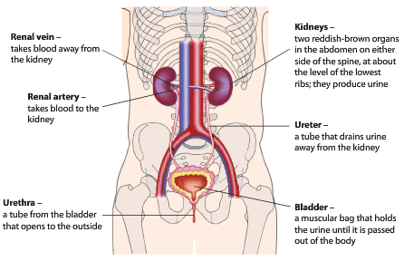
- Production of some hormones (erythropoietin)

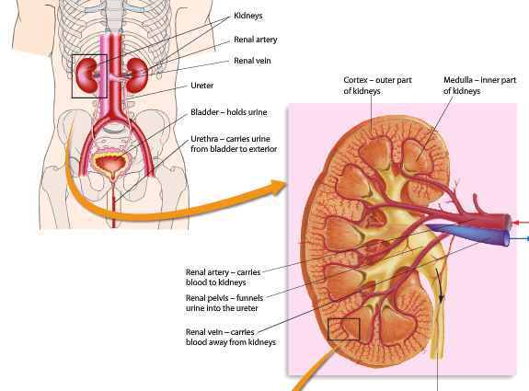

The Nephron
- Each kidney contains 1.2 microscopic units called nephrons
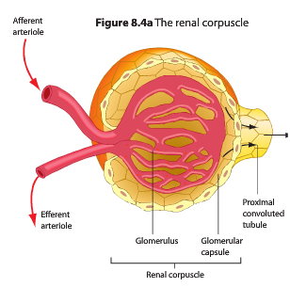
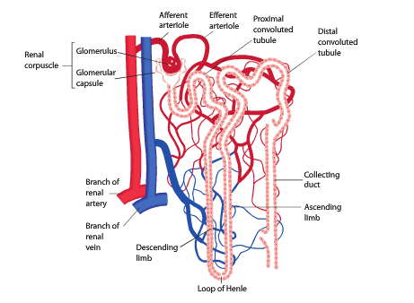
- The nephron is the functional unit of the kidney and carries out the kidneys role in excretion and water regulation.

Formation of Urine
- The formation of urine by the nephrons of the kidney involves three major processes
- Glomerular Filtration
- Tubular Secretion
- Selective Reabsorption

Glomerular Filtration
- Filtration takes place in the glomerular capsule. Blood in the glomerulus is under high pressure as the afferent arteriole is wider the efferent arteriole and the renal artery is connected directly to the aorta.
- The higher pressure forces small molecules like water, glucose, amino acids, urea, sodium, potassium and hormones across the membrane of the glomerulus capsule.
- This fluid is termed filtrate
- Larger molecules like erythrocytes, leptocytes, platelets and proteins are to large to pass through the membranes and remain in the glomerulus. They move out of the efferent arteriole.

Selective Reabsorption
- Many substances in the filtrate are useful to the body and therefore are returned to the blood by selective reabsorption.
- In the proximal convoluted tubule, glucose, amino acids, sodium, potassium, chloride and bicarbonate ions are selectively reabsorbed by active transport and water is reabsorbed by osmosis.
- The Loop of Henly is responsible for the reabsorption of sodium back into the tissue fluid, this helps maintain suitable conditions for the removal of water by osmosis from the filtrate as it moves down the collecting duct.
- In the distal convoluted tubule, sodium is reabsorbed by active transport and water by osmosis under the influence of ADH (anti-diuretic hormone).
- In the collecting duct, water is reabsorbed by osmosis under the influence of ADH, urea is not absorbed and it passes out as urine.

Tubular Secretion
- Selective reabsorption removes substances from the filtrate into the blood. Tubular secretion adds materials to the filtrate from the blood.
- Tubular secretion can be active or passive.
- Occurs in the distal convoluted tubule. Unwanted substances such as; hydrogen ions, nitrate, potassium ions, creatinine and other drugs such as penicillin are added to the filtrate.

Tubular Secretion and pH levels
- The body must maintain the blood within a pH range of 7.4-7.5 despite the fact that our diets usually contain acid producing food.
- To raise the pH of the blood tubules, secrete hydrogen and ammonium ions into the filtrate. These two substances make the urine slightly more acidic.

Fluid Balances
- Fluid gain must be equal to the fluid loss if the body’s composition of fluids is to remain fairly constant.
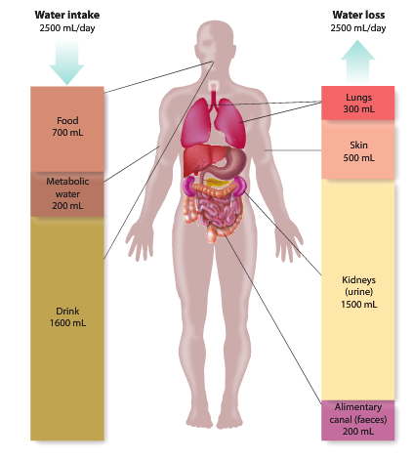

Water Balance
- The level of water in the plasma and tissue fluid is regulated by varying the amount of water taken into the body (drinking) and the amount reabsorbed from the filtrate in the nephron tubules.
- Osmoreceptors in the hypothalamus detect the osmotic potential of the blood. The hypothalamus controls the secretion of ADH from the posterior pituitary.
- Water is mostly reabsorbed from the filtrate in the distal convoluted tubule and the collecting duct. Some of the water moves naturally because of concentration gradients. Some water reabsorbed is controlled by the level of ADH in the blood.

Anti- Diuretic Hormone
- ADH increases the amount of water reabsorbed from the tubular filtrate back into the plasma. This is achieved by increasing the permeability of the walls of the distal convoluted tubule and collecting duct. This allows more water to be reabsorbed back into the blood meaning less urine.
- Water levels in the body fluids change the osmotic pressure of the blood.

High water level- steadily state control mechanism

Low water level- steadily state control mechanism

Thirst mechanism

Regulation of Breathing

Breathing Rate
- Breathing rate is varied by the body to help maintain a constant level of carbon dioxide and oxygen
Why must constant levels of CO2 and O2 required?
- O2: required by cells for respiration
- CO2: Is a waste product of cellular respiration which if allowed to accumulate decreases cell efficiency

Control of Breathing Rate
- The concentration of carbon dioxide in the blood is the main stimulus for breathing rate
Component | How it controls breathing | Location
Chemoreceptors | Detect changes of CO2 levels in the blood | Aortic and Carotid bodies  Respiratory centre
Respiratory centre | Controls breathing rate and depth | Medulla
Stretch receptors | When stimulated by stretching lungs causes expiration (protective function) | Lungs
- High carbon dioxide produces carbonic acid which makes blood slightly acidic therefore decreasing the pH.
- If CO2 levels are high (decreasing in pH levels) (when exercising) breathing rate increases
- If CO2 levels are low (increasing the pH levels) (when resting) breathing rate decreases

Control of Breathing
Chemoreceptors, stretch receptors and respiratory centre helps to control breathing rate in the following ways

The control of breathing during exercise (high CO2, low pH)

The control of breathing during rest (low CO2 and higher pH)

Other factors effecting breathing
- Cortex area of the brain (conscious control)
- Sudden pain or cold (increases rate)
- O2 levels (must be large variations)
- Moving of joints and muscles (more movement = increased breathing rate

Voluntary control of breathing
- Breathing rate can also be voluntary controlled.
- This is initiated by the cerebral cortex
- The cerebral cortex sends nerve impulse via spinal nerves to directly to the respiratory muscles to decrease and increase breathing

Hyperventilation
- Hyperventilation is rapid, deep breathing to decrease the amount of CO2 in the blood (is has little effect on the concentration of oxygen)
- It is especially dangerous to hyperventilate and then go underwater.
- Because of the low initial concentration of carbon dioxide in the blood, it would take a long time for carbon dioxide to build up to a level at which the decrease pH of blood would stimulate the respiratory center to make you take a breath.
- During this time your oxygen concentration may decrease to such a level that you pass out before the urge to take a breath occurs.
- Then, when you are forced to breathe, you will take in water and drown.
- Many drowning deaths in Australia have been the direct results hyperventilation.

Heart Rate and Blood Pressure

Heart Rate: the number of times the heart beats per minute.
Stroke Volume: The amount of blood forced from the ventricles with each contraction.
Cardiac Output: the amount of blood leaving the heart each minute.
Stroke volume (mL) x heart rate (bpm).
Venous return: the amount of blood returning to the heart.
Blood pressure: is the forse with which the blood presses on the walls of the blood vessels.

Control of heart rate and blood pressure

BLOOD PRESSURE AND HEART RATE ARE CLOSELY RELATED
Main factors that influence cardiac output | and blood pressure and their receptors
Factor | Receptor
Carbon dioxide levels/pH of blood | Chemoreceptors (carotid arteries)
Blood Pressure | Pressoreceptors/ Baroreceptors (aortic and carotid arteries)
Pain | Pain receptors
Movement of muscles and joints | Proprioceptors
Venous returns | Receptors in the heart
Emotions | Created in the cerebral cortex

Main modulator
- Cardiovascular regulating centre (found on the medulla)
Reuglates;
- Heart Rate
- Stroke Volume
- Diameter of arteries

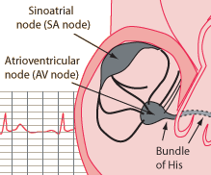
SA Node
The SA node is often described as the pace maker of the heart as it is responsible for the rhythmic contractions of the heart

Increasing heart rate/ cardiac output

Decreasing heart rate/ cardiac output

Homeostatic control of blood pressure (decrease)

Homeostatic control of blood pressure (increase)

Other factors affecting heart rate
- Age
- Sex
- Emotional state

Blood Sugar Regulation

Issues with being too high or low
- If glucose levels are too low (hypoglycaemia) then cellular respiration and metabolism slows, energy levels drop, limiting the cells activity. The brain is very susceptible to low levels of glucose. Mental confusion, unconsciousness and seizures may result.
- If glucose levels are too high (hyperglycaemia) can cause damage to nerves, kidneys and eyes.

Blood sugar regulation
- Blood glucose levels must remain constant in order to maintain metabolic processes in the cell (cellular regulation).
- All cells need a constant supply of glucose as it is a sources of energy for the cells activities (movement, reproduction, synthesis)
- Glucose can be derived from carbohydrates in the digestion process.
- Glucose comes from the digestive system via the hepatic portal vein to the liver where;
- Glucose may be used in liver cells
- Glucose may be converted into glycogen for storage in the liver or muscle cells
- Glucose may circulate through blood for cellular use (cellular respiration)
- Glucose may be converted into fat
- The Islets of Langerhans have special cells (alpha and beta) in the pancreas which have a number of roles. They have chemoreceptors that detect the level of glucose in the blood.
- If blood glucose levels are low, alpha cells, in the islets of Langerhans produce glucagon. Glucagon acts in a number of ways to increase blood glucose levels.
- If blood glucose is too high, beta cells, in the islets of Langerhans produce insulin. Insulin acts in a number of ways to decrease the blood glucose levels.

Adrenal Cortex: Produces hormone called Cortisol
Adrenal Medulla: Produces the hormone called Adrenaline

Role of glucagon
- Glucagon acts to raise blood glucose levels by the following processes
- Glycogenolysis: Breakdown of glycogen into glucose
- Lipolysis: Breakdown of lipids into glucose
- Gluconeogenesis: Production of glucose from fatty and amino acids.

Role of Insulin
- Insulin acts to lower blood glucose levels by the following processes
- Glycogenesis: Glucose molecules combine to make glycogen
- Lipogenesis: Glucose converted to lipids
- Protein Synthesis: he processes by which amino acids are linearly arranged into proteins
- Translocation: Glucose moves from blood into cells.

Energy Sources

Glucose: Simple carbohydrate used in cellular respiration
Glycogen: complex carbohydrate used to store glucose in cells and liver
Lipids: Fats used to store excess energy broken down when required
Proteins: Amino acids can be deaminated to produce ammonia and carbohydrates

Hormones

Insulin: Hormones processed by beta cells that lower blood glucose levels. Glucose to glycogen
Glucagon: Hormones processed by the alpha cells that raises blood glucose levels. Glycogen to glucose.
Cortisol and Adrenaline: Hormones act to raise blood glucose levels.

High levels of glucose (after a meal)

Low levels of glucose (during exercise)

Role of the Adrenal Glands in raising blood glucose levels

The adrenal glands are located above the kidney
There are two main part
- The adrenal cortex: secretes cortisol
- Adrenal medulla: secretes adrenaline and noradrenaline
Both have a role in raising blood glucose levels.
The adrenal gland is normally stimulated by the sympathetic nervous system (stress related)

Disruption of Homeostasis

Hormonal causes of disruption
- Many hormones are involved in homeostasis
- Insulin and Glucagon- regulate blood glucose levels
- Thyroxin regulates metabolic rate
- ADH regulated fluid levels
- Too much or too little of these hormones can cause major disruptions to homeostasis. Major examples include
- Diabetes
- Hypothyroidism
- Hyperthyroidism

Diabetes Mellitus
- Diabetes mellitus occurs when an individual has abnormally high blood glucose levels – Hyperglycaemia
- If a person produces insufficient insulin or if their cells are resistant to the effects of insulin, then blood glucose levels remain high
- This results in a large amount of glucose in urine
- There are two forms of diabetes; type 1 + type 2.
Type 1
- Can be referred to as insulin-dependent
- Usually begins in childhood
- Results from the patient’s immune system destroying the beta cells in the Islets of Langerhans
- People with type 1 diabetes do not produce insulin
- The patients cell still respond to insulin in the normal way

Type 2
- Referred to as adult onset diabetes as it usually develops in people over 45.
- Patients are able to produce insulin but cells don’t respond to it. As a result, insulin is not taken up by the cells.
- Type 2 diabetes is a lifestyle disease more common in overweight individuals.
- Life style risk factors include;
- Lack of physical activity
- Overweight
- High sugary, fat and salt diet
- High blood pressure
- High blood cholesterol
- Smoking
- Type 2 diabetes develops gradually and often there are no symptoms
- If the condition remain undiagnosed or untreated risks include;
- Heart disease
- Stroke
- Kidney disease
- Eye problems
- Nerve damage
- Skin and foot problems

Treatment of type 2 diabetes
- Treatment involve a management program to maintain glucose levels within a normal range
- Management includes
- Careful diet
- Physical activity
- Healthy weight
- Monitoring blood glucose
- Medication if blood glucose can’t be controlled by other measures

Treatment of diabetes using synthetic hormone
- Type 1 and sometimes type 2, are usually treated with injections of insulin
- This insulin used to be obtained from the pancreas of cows and pigs
- Insulin supply by this method was expensive and limited
- There had to be purified and some people, suffered from allergic reactions or infections from the animal derived insulin
- In the 1980’s production began on genetically engineered human insulin
- This was done using a process caleed recombinant DNA technology
- The gene for human insulin was inserted into bacterial DNA
- The bacteria were cultured to make human insulin using the recombinant DNA
- Yeast is now used in a similar way
- Almost all insulin used globally now is biosynthetic recombinant ‘human’ insulin rather the animal insulin.

 | Type 1 | Type 2
Description | Hyperglycaemia | Hypoglycaemia
 | Beta cells are destroyed by the immune system and therefore do not produce insulin (autoimmune disease). Glucose is unable to move into cells. | Beta cells produce some insulin. Insulin receptors become desensitised and insulin is unable to move into cells /cells become resistant to insulin.
Age of onset | Childhood (peek at 12) | Middle Ages (over 45)
Cause/ Risk factors | Genetic link  Cause unknown | Lifestyle factors  Eg. Lack of exercise/ poor diet.
Symptoms | Symptoms may include excessive thirst and urination, unexpected weight loss, weakness, fatigued and blurred vision. | Excessive thirst  Excessive urination  Tiredness  Hunger  Slow healing of cuts  Skin infections
Management | Regular insulin injections  Programmable group | Diet low in fat, salt and sugar  Exercise  Maintain a healthy weight  Medication
Complications | Heart disease, kidney disease, blindness, nerve damage, circulation problems | Heart disease, kidney disease blindness, nerve damage, circulation problems

Excess and deficiency of thyroid hormones
- The thyroid gland is responsible for secreting the hormones thyroxin and tri-iodothyronine
- Both have the same effect, the major form released is thyroxin
- Thyroxin effects nearly every tissue by stimulating carbohydrate, protein and fat metabolism.
- Therefore, the secretin or thyroxin controls basal metabolic rate and therefore plays an important role on the long term homeostasis of body temperature
- An excess of deficiency of thyroxin can cause disorders. In some cases, the imbalance of thyroxin can be due to an imbalance in TSH.

Hyperthyroidism- Too much thyroxin
- Occurs due to an overproduction of thyroxin by the thyroid gland.
- The most common form of hyperthyroidism is called graves’ disease. This is an enlargement of the thyroid gland due to an immune system reaction.
- Graves is not inherited but there does seem to be a genetic predisposition for the condition
- Symptoms include;
- Rapid heart rate
- Weight loss
- Increased appetite
- Fatigue
- Sweating
- Anxiety
- Protruding eyeballs
Treatment;
- Use of drugs that block the thyroid glands use of iodine
- Surgery to remove some or all of the thyroid gland
- Giving the patient a drink containing radioactive iodine
- The radioactive iodine molecules are taken up by the thyroid cells which are then killed by the radioactivity
- Other body cells do not take up iodine and are therefore unaffected.
- The radioactive iodine is eventually excreted in the urine.

Hypothyroidism- Too little thyroxin
- Hypothyroidism is more common the hyperthyroidism
- 6-10% of Australian women and a smaller proportion of men may be affected.
- Occurs due to problems with the thyroid or pituitary gland.
- Symptoms include;
- slow heart rate
- weight gains
- lack of energy
- intolerance to coldness
- swelling of the face
- goitre (swelling of the neck- due to enlargement of the thyroid gland.
- One source of thyroid gland problems is lack of iodine
- A thyroxin molecule contains 4 iodine atoms and tri- iodothyronine contains 3 iodine atoms.
- Therefore, a lack of iodine in the diet can prevent the thyroid gland from making enough hormones.
- Hypothyroidism in this case can be treated by inclusion of iodine in diet.
- The most common cause of hypothyroidism is an attack on the thyroid gland by the patient’s own immune system – Hashimotos disease
- Another cause is the surgery removing part or all of the thyroid gland due to cancer.
- To treat these cases of hypothyroidism patients are prescribed tablets containing thyroid hormones.
- As there is no cure these tablets must be taken for the rest of the patients life.
- The dose of thyroid hormone must be carefully monitored to balance relief of the symptoms of hypothyroidism without administering too much and resulting in hyperthyroidism.

Treatment of hypothyroidism using synthetic hormones
- Treatment used to be using tablets made from the dried and powdered thyroid glands of animals (pigs)
- These contained both T3 and T4 but not necessarily in the same proportions as produces in humans.
- Traces of other hormones may also be present.
- Mors patients are now treated with hormones made synthetically using a chemical process.
- Levothyroxine is the most commonly prescribed drug for thyroid hormone replacement- this is synthetic form of thyroxin (T4)

IMMUNIE SYSTEM, INFECTION AND BIOTECHNOLOGY

DEFENSE

Communicable Diseases
- Communicable or infectious diseases are desieses caused by foreign organisms that invade the body and multiply there.
- Disease causing organisms/ agents are called pathogens.
- Some pathogens are passed on from person to person, these diseases are refered to as contagious.
- Other pathogens are spread from person to person by an intermediate host called a vector eg. Insects (mosquito), mits or fleas.

Pathogen | Disease causing organism or agent
Communicable | Disease caused by foreign organisms invading body and multiplying
Contagious | Disease passed on by direct contact with infectious person or by contact with something the individual has touched.
Vector | Intermediate host of a pathogen, such as an insect, capable of transferring a disease- causing organism from one person to another.

Pathogens
- Pathogens are disease causing organisms or agents.
- The most common pathogen to affect humans are bacteria and viruses
- Fungi and Animal parasites can also infect humans but are less common.

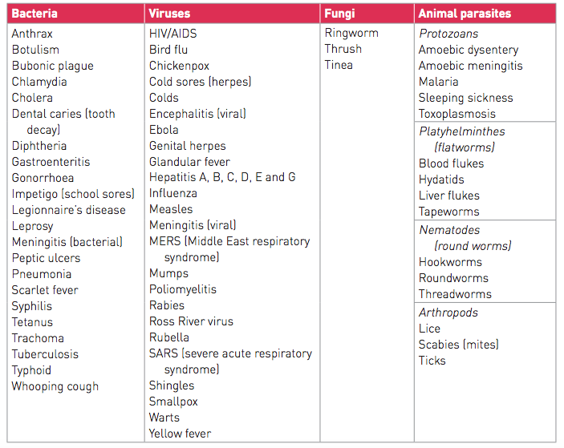

Bacteria
- Bacteria are living, single celled organisms that have a cell membrane, a cell wall and a DNA genome.
- Bacteria can reproduce independently of other living cells.
- Not all bacteria are pathogenic, some are even beneficial to humans.
- However some bacteria are pathogenic and can cause illness and death when present even in relatively small numbers.
- E Coli, on average bacterial cell is 1um wide and 5-6um long.

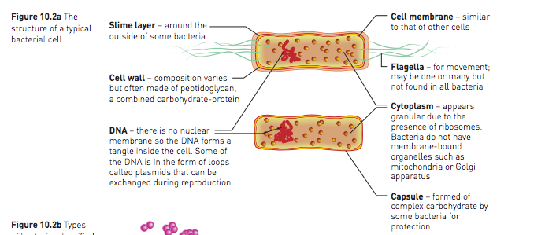

Bacterial Classification
- Bacteria are classified based on the shape they are seen under a light microscope
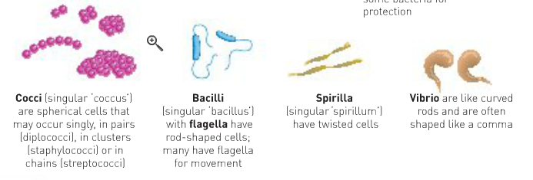

Viruses
- Viruses are small non-living particles consisting of genetic material surrounded by a coat of protein.
- Characteristics of viruses are that:
- They done have a true cell membrane or cell wall.
- Genetic material is in the form of DNA and RNA.
- They have a surrounding coat of protein.
- Viruses infect living cells and induce them to make more virus particles. The new virus particles can then go on to infect other cells.
- As viruses are dependent on living host cells for reproduction they are considered non-living.
- Viruses are small structures unable to be observed under a light microscope. Viruses are much smaller then bacteria. Some viruses even infect bacterial cells.
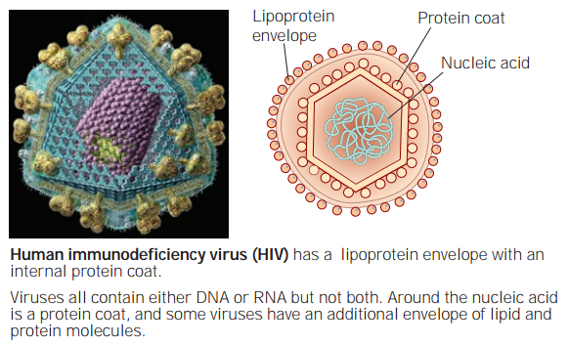

Viral Reproduction
- Viruses insert their DNA into the DNA of the host cell
- This causing the host cell to
- Translate and Transcribe viral genes to make viral protein
- Copy viral DNA
- This forms (can be millions) of new virus particles that are released and go on to infect new cells
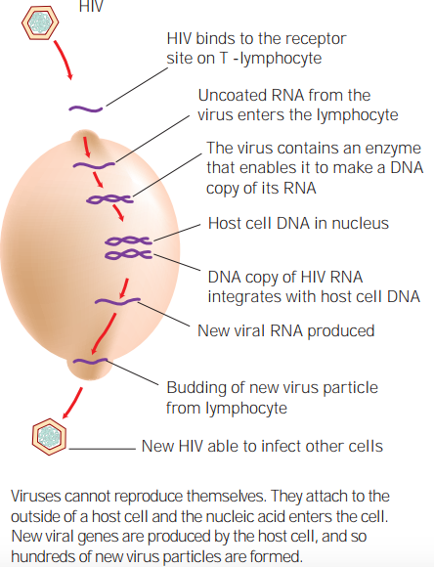

Bacteria | Virus
Living organism  larger  Unicellular  Mostly not harmful  Treated with antibiotics  Pneumonia, whooping cough etc. | Non-living  Smaller  Require a host cell for reproduction  Measles etc.

Fungi | Animal Parasite
Relatively few are pathogenic  Treated with anti-fungal medication | Organisms that live on or in another living thing and gain food/shelter from it.  Two types  Ectoparasited: live on the surface (lice)  Endoparacites: live inside the body (ringworm)

Transmission of Pathogens
- Communicable diseases are spread by transferring pathogenic organisms from one to another. This can occur in a variety of ways;

- Transmission by Contact: Involves the spread of pathogens by actual physical contact. The contact could be direct or indirect. Common with skin infections or STI’s.
- Transmission of Body Fluids: When blood or body fluids from an infected person comes into contacts with the mucous membrane or bloodstream if an uninfected individual. Pathogens may enter the body. Hepatitis B
- Infection by Droplets: Occurs when tiny droplets of moisture, containing pathogenic organisms are emitted by an infected individual (breathing, talking, coughing, sneezing). The droplets may be breathed in by others or may settle on food or utensils and ingested. Measles, colds etc.
- Ingestion: Consuming food or drink infected by pathogens. Salmonella
- Airborne Transmission: When the moisture in exhaled droplets evaporated viruses and some bacteria remain visible and can result in infection when inhaled.
- Transmission by Vectors: When pathogens are transferred by other animals, such as insects, ticks or mites, this can be direct or indirect. Many vector- borne diseases are spread by a specific vector. Malaria- mosquitos.

- Not all human pathogens are transmitted from human to human, some infect animals and can be transmitted from them.
- These pathogens are referred to as zoonotic.
- When a pathogen is transmitted from an anima to a human it is referred to as zoonotic.
- An example is salmonellosis caused by salmonella bacteria and Rabies caused by lyssaviruses.

Disease Defence System

Defence Against Disease
Two types of defences:
- Non Specific Defences: Defence that work against all pathogens. The body’s first line of defence.
- Specific Defences: Defences that are directed at a particular pathogen.

Non- Specific Defence
External Defence
- Barriers preventing access to the body
- Protective reflexes
- Blood clotting
Internal Defence
- Phagocytes
- Inflammatory Response
- Fever

External Defences
- The body has a variety of external defences that try to stop pathogens from entering the body.
- These include;
- Skin, Mucous Membrane, Hair, Cillia, Acids, Lysozyme, Cerumen, Flushing Action

Body’s non-specific external defence against entry of pathogenic micro-organisms
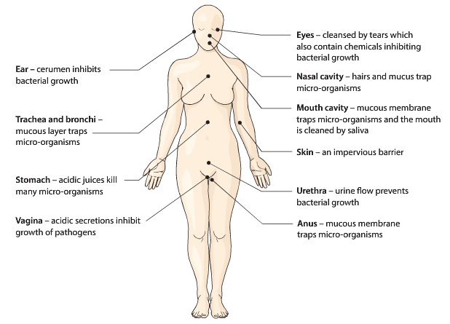

Non-specific, External Defences
Skin:
- The skin is a physical barrier that prevents the entry of micro-organisms into the body.
- Large numbers of bacteria occupy the skin, as a result pathogenic bacteria cannot easily become established.
- Oil glands in the kin produce a secretion called sebum containing antibacterial substances.
- Sweat secretions onto the skin contain salts and fatty acids that prevent growth of the microorganism.

Mucous Membrane: Line body cavities that open to the exterior. They secrete mucous, which inhibits the entry of microorganisms the organs and the body. Digestive urinary and reproductive tracts are protected this way.

Hairs: Found in the nasal cavity and ears, combined with a thin layer od mucous trap up 90% of particles when breathing

Cillia: Tiny hair like projections from cells that line the mucous membranes of air passages. The beating of the cilia moves mucous containing trapped particles and microorganism towards the throat to be coughed up or swallowed.

Acids: The strong acidity of the stomach juices kills many bacteria swallowed. Acid secretions of the vagina and within sweat also inhibits microbial growth.

Lysozyme: Lysozyme is an enzyme that kills bacteria. Lysozyme is found in tears, saliva, sweat gland secretions and tissue fluid.

Cerumen (ear wax): Protects the outer ear from infection by bacteria, it is slightly acidic and contains lysozyme.

Flushing Action: The flushing action of body fluids keeps some areas mostly pathogen free. Urine flowing through the urethra prevents bacteria from reaching the bladder and kidney.

Non-Specific Defence- Blood Clotting: Creates a physical barrier for entry of pathogens

Minor Injury
- Small blood vessels constrict- blood flow reduced.
- Damaged blood vessel walls get rough- platelets stick to walls
- These platelets attract other platelets- forming a plug- further reduction in blood loss
- Platelets release chemicals causing vasoconstriction. Prolonging the constriction of the vessels around the wound.

Serious Injury
- Coagulation occurs: clotting factors cause a series of reactions that result in the formation of threads.
- Threads form meshwork that traps blood cells, platelets and plasma ie. Clot.
- Threads stick to damaged blood vessels and hold clot in position.
- Threads contract and pull the edges of the blood vessel together (clot retraction)
- Serum is squeezed out, clot dies, scab forms which prevents entry of microorganisms.

Protective Reflexes
- Sneezing
- Coughing
- Vomiting
- Diarrhoea

Internal non-specific defence
- If pathogens get past the external defences, there are internal non-specific defences that act against them
- Phagocytes
- Inflammatory response
- Fever

Phagocytes
- Phagocytes are cells that can engulf and digest microorganisms and cell debris. By the process of phagocytosis
- These include Leucocytes and Macrophages
- Leucocyte such as a neutrophil are white blood cells, they are able to leave the blood capillaries and migrate through tissues to place of infection or injury.
- Macrophages are large phagocytic cells that develop from leucocytes. Some of them move through tissue looking for pathogens and destroy them. Others remain in a fixed place and engulf pathogens that come to them.

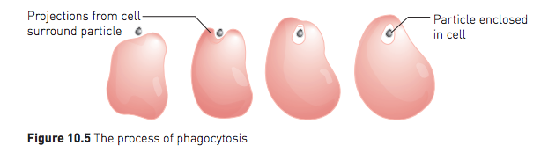

The inflammatory response
- Inflammation is a response to the damage of tissues. Inflammation acts to:
- Reduce the spread of pathogens, to destroy them and prevent the entry of additional pathogens.
- Remove damaged tissue and cell debris
- Begin the repair of damaged tissue.
- There are four signs of inflammation occurring in a tissue. They are:
- Redness, swelling, pain and heat.
- When tissue becomes damaged a series of steps occur to initiate an inflammatory response.

- When stimulated by mechanical damage or local chemical changes, mast cells release histamine and heparin and other substances into the tissue. Mast cells are specialised cells that are present in most tissue. They stimulate and coordinate inflammation by released chemical’s.
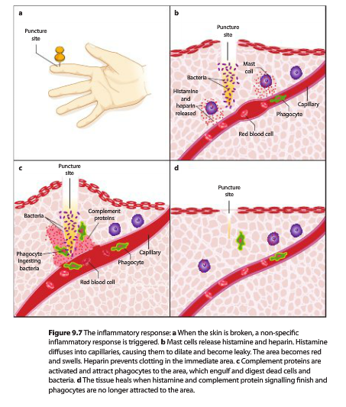
- Mast cells release histamine and heparin. Histamine diffuses into the capillaries causing them to dilate (increasing the blood flow to the area) and makes them more permeable (leaky). Heparin prevents clotting in the immediate area.
- Chemical released from mast cells attract phagocytes. Macrophages and Leucocytes actively consume micro-organisms.
- The abnormal conditions in the tissue stimulate pain receptors so the person fells pain in the inflamed area.
- Phagocytes filled with bacteria and dead cells begin to die. The dead phagocytes and tissue from fluid form a yellow liquid called pus.
- New cells are produced by mitosis and repair damages tissue.

Fever
- Fever is the elevation of body temperature that can occur during the course of an infection.
- This is caused by resetting of the bodies thermostat (controlled by the hypothalamus) to a higher level.
- During fever a person fells cold and vasoconstriction in the skin and shivering occurs pushing body temperature up rapidly.
- The point at which a fever breaks is called the crisis, at this point the thermostat is reset to normal.
- The person then fells hot and skin vasodilation and sweating occurs.
The benefits of fever
- High body temperature is thought to inhibit the growth and spread of bacteria and viruses.
- Heat speeds up the rate of chemical reactions allowing body cell repair to occur more quickly during disease.
- If fever gets too high fever can become harmful. If body temperature reached 44.4-45.5 degrees’ death is likely.

The lymphatic system
The lymphatic system consists of:
- A network of lymph vessels capillaries joined to larger lymph vessels.
- Lymph nodes, which are located along the length of some lymph vessels
The main function of the lymphatic system is to collect some of the fluid that escapes from the blood capillaries and return it to the circulatory system.
The lymphatic system is also an important part of the bodies internal defence against pathogens.

Lymph Vessels
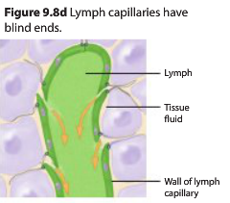
- Excess fluid in the tissue is returned to the body through the lymphatic system.
- Fluid returned to the body in this way is known as lymph.
- Unlike the circulatory system, lymph doesn’t circulate- lymph is a oneway system carrying fluid away from the tissues.
- Lymph vessels are blind ended tubes in the space between the cell of most tissues.
- Lymph vessels are slightly larger and more permeable than blood capillaries.
- Protein and disease-causing organisms in the intercellular fluid can easily pass through the walls of the lymph capillaries.

Lymph Nodes
- Lymph nodes occur at intervals along the lymphatic vessels.
- They are most numerous in the neck, armpits, groin and alimentary canal.
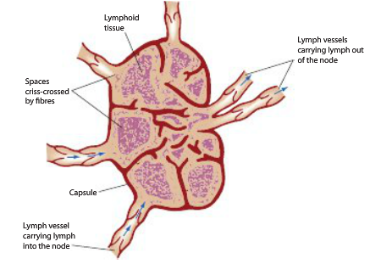
- A lymph node is surrounded by a capsule of connective tissue that extends into the node, forming a frame work.
- Within the tissue are masses of lymphoid tissue, containing cells known as lymphocytes, macrophages and plasma cells.
- Spaces between the cells of the lymphoid tissue are crisscrossed by a network of fibres.
- Lymph enters through the vessels on the convex side of the node, filters through the spaces and passes out the opposite side.
- Lymph passes out through several nodes before entering the circulatory system.

Transport of Lymph
- Lymph is pushed along lymph vessels by the squeezing action of skeletal muscles.
- Valves prevent backflow.
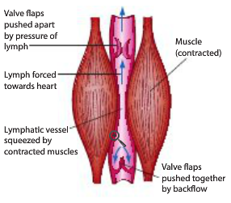

Role of the lymphatic system in non-specific defence
- Some micro-organisms that make their way into the lymph can be pathogenic, if not destroyed they can cause disease, if not destroyed they can cause disease.
- Larger particles, such as bacteria are trapped in the meshwork of the fibres as the lymph flows through the spaces of the nodes. Macrophages destroy these particles by injecting them through phagocytosis.
- When infections occur the formation of lymphocytes increases and the lymph nodes become swollen and sore. Most lymphocytes are important in the specific immune response to a pathogen.

Specific Defence
- Specific defences: Defences that are directed ar a particular pathogen.
- If a pathogen manages to get past non-specific defences (skin, mucous membranes and phagocytes) then a specific response is established.
- Specific responces can be
- Antibody Mediated (humoral) immunity
- Cell Mediated Immunity

- Pathogen: a disease causing organism or agent
- Antigen: A substance on the surface of a pathogen capable of causing a specific immune response (causes the body to produce a specific immune response).

An antigen is a large molecule, it can be:
- Protein, carbohydrate, lipid or nucleic acid
- A virus particle, or part of
- A whole micro-organism eg. Bacteria
- Part of a bacteria – cell wall, flagella, capsule
- Toxin produces by bacteria
- Other persons tissue
- Pollens

Self-Antigen: large molecule produces in a person’s own body. They do not cause an immune response.
Non-Self Antigen: foreign molecule that does trigger an immune response.

Specific Immune Response
- Response designed to be affected against a specific pathogen
- Antigens are substances that cause production of antibodies (specific immune response)
- An antibody is a protein that is produces in response to non-self-antigen
- Antigen- antibody complex: Antigens have specific active sites at these sites antibodies can combine with the antigen – lock and key

There are two types of specific defence
- Antibody Mediated or Humoral Immunity
- Involves mainly B cells (B-lymphocytes)
- Occurs when foreign substances or micro-organisms are in the blood lymph or tissue fluid.
- Cell Mediated Immunity
- Involves mainly T cells (T-Lymphocytes)
- Occurs when pathogens have entered the cell.

Lymphocytes and Macrophages
- There are two types of leucocytes (white blood cells) involved in specific defence, Lymphocytes and Macrophages.
- Lymphocytes comprise 20-30% of the white blood cells in the blood, most lymphocytes in the body are usually found in the lymph nodes.
- Blood lymphocytes roam through the body moving freely between the blood and tissues.

Lymphocytes
- Lymph node lymphocytes are involved in detecting particular pathogens and making specific antibodies and killer cells.
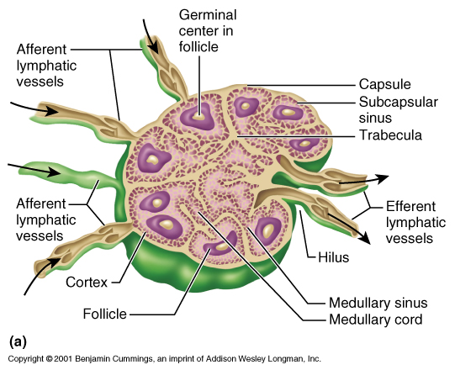

Macrophages
- Macrophages are large phagocytic cells that consume foreign substances and micro-organisms by phagocytosis ie. Non-specific.
- They are also involved in specific defence by alerting the immune system to the presence of foreign materials in the body.

Origin of Lymphoid Tissue
- There are two types of lymphoid tissue
- B Lymphocytes
- T Lymphocytes
- All lymphocytes are formed (born) in the bone marrow.
- Lymphocytes that stay in the bone marrow develop and mature and care called B-Lymphocytes.
- Immature (baby) lymphocytes that migrate from the bone marrow to the thymus are called T Lymphocytes.
- Both B and T Lymphocytes migrate to the lymphoid tissue and nodes once matured.
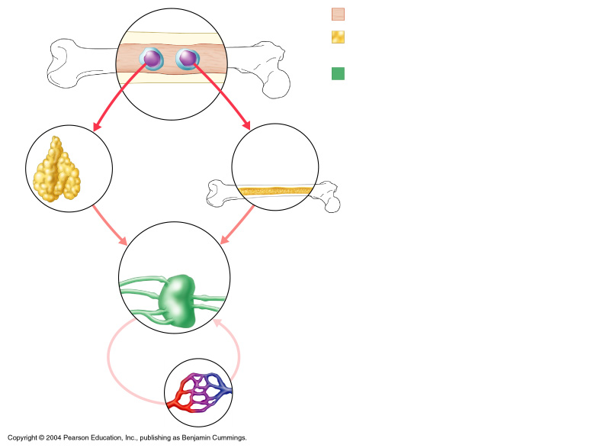

B Cells and T Cells
B Cells: A type of lymphocyte that develops into either plasma cells that produce antibody’s or into memory cells.
T Cells: A lymphocyte that can differentiate into a number of different kinds of cells, all of which are involved in cell mediated immunity.
Recognition (Antigens and Antibody’s)
Antigens:
- An antigen is a substance capable of causing a specific immune response.
- Every cell has molecules or “special patterns” on the outside of the cell membrane.
- These patterns are called antigens.
- Your body is able to recognise the difference between its own “self antigens” and “non- self” antigens.
- There are special cells in the lymph nodes that detect invading organisms by recognising “non-self” antigens.
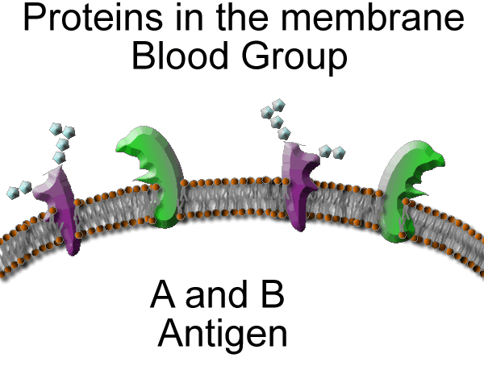

Antibody’s:
- Antibodies are specialised proteins that are produces in response to non-self antigens.
- Antibodies belong to a group of proteins known as immunoglobulins (lg) that are classified by structure
- Antibodies are designed as either IgG, IgA, IgE, IgD or IgM
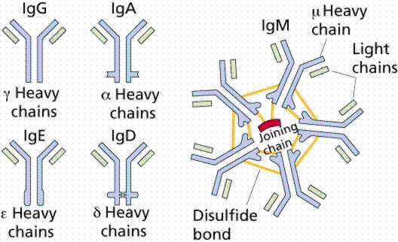

- An antibody produced in response to an antigen can combine with that antigen to form an antigen-antibody complex.
- Antigen molecules have specific active sites that combine with the matching antibody ie. Lock and key model.
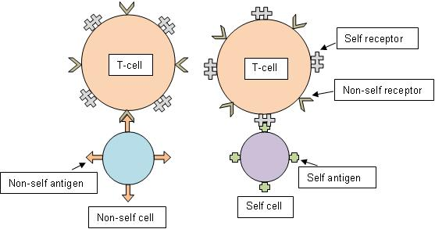

Antibody Mediated (humoral) Response
- Antigen enters the body and is recognised by a particular antibody on a B lymphocyte (this process is helped by helper T cells)
- B lymphocyte becomes sensitised, they enlarge and divide (clone) and change function.
- Most become plasma cells that secrete antibodies which circulate in blood and lymph. Others become memory cells that remain in tissue to respond rapidly should that antigen enter the body again.
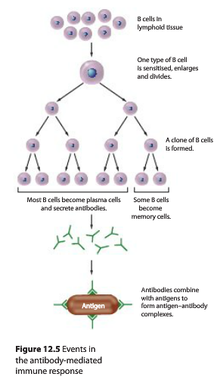

Primary and Secondary Response (antibody mediated response)
Primary Response: is the first exposure to an antigen which is a slow response
Secondary Response: due to memory cells the second response to an antigen is fast and most cases the antigen has little to no effect on the body; no illness results.

The antibody levels in blood plasm after a first and second exposure

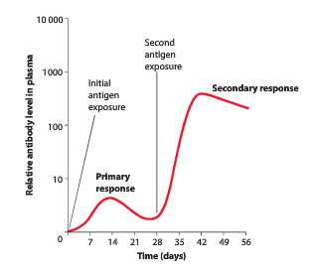

The response that then occurs varies according to the particular antibody
Antibodies may:
- Inactivate foreign enzymes or bacterial toxins
- Bind to viruses preventing them from entering cell
- Coat bacteria so they are easily consumed by phagocytes
- Cause particles to clump together- agglutination
- React with soluble substances to make them insoluble and thus more easily consumed by phagocytes.
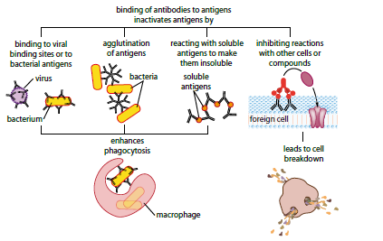

T Cells (Cell Mediated Immunity)
- Cell mediated immunity provides resistance to the intracellular phase of bacterial and virus infections where pathogens invade and replicate inside their hosts own cells.
- Cell- Mediated Immunity is also important in providing resistance to fungi and animal parasites, and is involved in the rejection of transplants and foreign tissue.

- When a B lymphocyte in a lymph node, or a macrophage in the plasma comes into contact with a foreign antigen it presents a fragment of it on the cell surface within a Major Histocompatibility Complex (MHC).
- The T cell binds to the MHC and antigen fragment
- The sensitised T lymphocyte divides and many start to develop into killer T cells.
- These spread through the body and actively migrate into tissues to the site of infection and hunt out invading organisms that have specific antigens that they are programmed to search for; including consuming the host cell; your cells that are infected.
- When they find them they either destroy them or attract leucocytes (macrophages) that destroy them.
- They are able to find them because they ‘know’ what antigen to look for
- The T-Lymphocyte eventually ‘dies’ but some of the clones remain and are called memory cells.
- The memory cells spread through the lymphatic system and inhabit each lymph node.
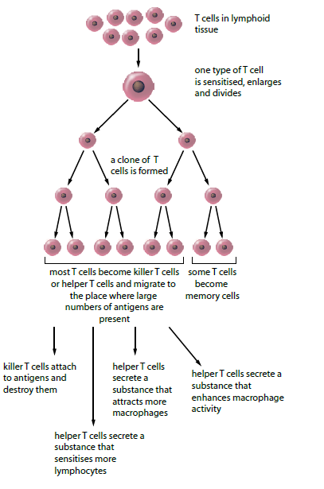

T Cell Action
- The T cells that do not become memory cells develop furter, producing three different types of T cells
- Killer T Cells- which migrate to the area of infection attaches to the antigen and destroys it
- Helper T Cells
- Secrete substances that sensitise more lymphosytes
- Secrete substances that attract macrophages
- Secrete substances that enhance macrophage activity
- Suppressor T Cells- inhibit T and B cells actively slowing or supressing immune response

IMMUNITY AND VACCINATIONS

Immunity
- Immunity is the resistance to infection by invading micro-organisms/agents.
- By initiating antibody mediated an cell mediated responses, the body is able to respond to the presence of pathogens before symptoms of disease occur.
- This rapid response is because, whenever T cells and B cells are activated, some of the cells become ‘memory cells’.
- The, the next time that an individual encounter that same antigen, the immune system is primed to destroy it quickly.
Immunity can be Natural or Artificial.
- Natural Immunity occurs without any human intervention.
- Artificial Immunity is a result from people giving antibody’s or antigens
Each type of immunity can further be classified as passive or active
- Passive Immunity Involves receiving antibodies from someone else. It is short lives as it only lasts until the antibodies are broken down and excreted.
- Active Immunity occurs when the body is exposed to a foreign antigen and manufactures antibodies in response to that antigen. It is long lasting as memory cells are created as part of the immune response allowing for rapid antibody production during future infection.
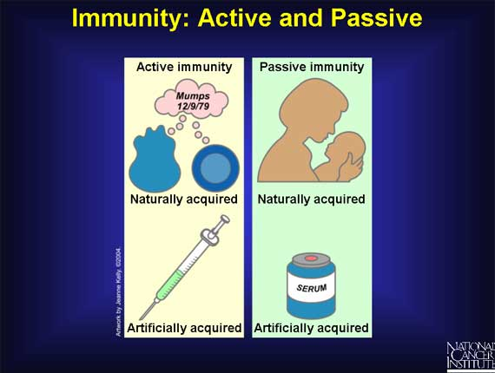
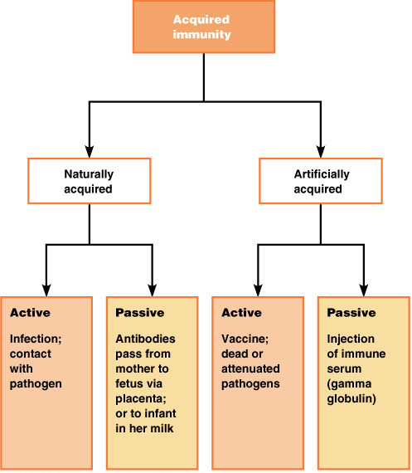

Active Natural Immunity (Infection)
- Body learns to produce antibodies after being exposed to a specific antigen.
- Symptoms present during first exposure.
- Immune system acts to create antibodies to specific antigen.
- Subsequent exposures cause antibodies to attack and destroy antigen before symptoms occur.

Active Artificial Immunity (Vaccination)
- Occurs through vaccinations
- Does not cause the disease, but it does cause the body to produce antibodies to the specific antigens.
- Dead or attenuated pathogens often used.

Passive Natural Immunity (Mother/Baby)
- Transfer of antibodies from mother to baby through placenta.
- Increased protection through breast-feeding.
- Protection lasts only a few months since baby’s body as not yet learnt how to produce antibodies.

Passive Artificial Immunity (Injection of antibodies)
- Inoculation with antibodies.
- Gives protection as long as antibodies are not used or eliminated from the system.
- Only used in diseases such as rabies or tetanus, or in the case of a snake bite.

Immunisation
Immunisation: Programming the immune system so it can respond rapidly to infected micro-organism
Vaccination: The artificial introduction of antigens of pathogens to a person so immunity (production of appropriate antibodies) is acquired without suffering illness.
Vaccine: An antigen preparation used in artificial immunity.

Types of Traditional Vaccines
- Living/functional attenuated micro-organisms or viruses
- This uses viable (living) pathogens with a reduced virulence (a reduced ability to produce disease symptoms).
- Examples include; Measles, Mumps, Rubella, Rabies, Poliomyelitis, Tuberculosis, Yellow Fever.
- Dead Micro-Organisms
- Pathogen is ‘killed’ with chemicals, heat, or radiation.
- These vaccines are more stable and safer than live vaccines: The dead microbes can’t mutate back to their disease-causing state.
- Most inactivated vaccines, however, stimulate a weaker immune system response than do live vaccines. So it would likely take several additional doses, or booster shots, to maintain a person’s immunity
- Examples include; Cholera, Bubonic Plague, Typhoid, Whooping Cough, Influenza, Hepatitis A.
- Toxids
- Some bacteria cause disease by releasing toxins.
- These toxins can be extracted and deactivated to form toxids.
- These toxids are used to form the vaccine
- Examples include; Tetanus
- Sub Units
- Instead of using the whole attenuated microbe, sub unit’s vaccines include only the antigen that best stimulate the immune system
- Examples include; Human papilloma virus, Hepatitis B
Vaccine Type | Description | Advantages | Disadvantages
Live Attenuated | - Consists of weakened virus or bacteria  - Doesn’t cause disease  - Stimulates immune response | - Natural immunity  - Long term | - Must be refrigerated  - Can revert to virulent form
Dead Micro-Organisms | - Contains either whole or part of killed virus or bacteria | - Stable and safe  - Easily stored and transported | - Weaker immune response stimulated  - Requires booster shots
Toxids | - Contains toxins produced by bacteria that have been inactivated | - Safer | - Weaker immune response  - Requires boosters
Sub Units | - Contains polysaccharides joined to immune-stimulating molecules | - Long lasting  - Protection for baby’s and toddlers | - Expensive and complex to produce

Vaccine Delivery
- The most common method is to inject the vaccine with a syringe.
- Polio vaccines have in the past been administered within a sweet syrup
- Methods being trailed for future delivery are
- Nasal Sprays
- Skin patches
- Genetic engineering of non-food plants to produce vaccines. This can be given to people to include food at a required dosage.

Vaccination and Antibody Mediated Immunity
First Exposure
- When a given vaccination, the antigens contained within the vaccine are detected by B-lymphocyte in a lymph node which becomes sensitised, enlarges and divides forming clones.
- This process is fairly slow on first exposure to the antigen.
- Due to the attenuated nature of the pathogens no or few symptoms of the disease being vaccinated against occur
- Symptoms occur before enough clones are made to produce antibodies (when naturally exposed)
- Symptoms decrease as antibody levels rise.
- Some of the clones remain in the original lymph node as B-lymphocyte memory cells, others migrate to other lymph nodes.

Second Exposure
- If a pathogen with the same type of antigen enters the body again (second exposure) the B-lymphocyte memory cells in the lymph nodes immediately detect the antigens, this is much faster as there are more B lymphocytes sensitive to the antigen.
- The B-lymphocyte starts forming antibody-producing clones which start ‘pumping’ out antibody.
- This results in more antibody’s being made faster and the pathogen being eliminated before it can cause symptoms of the disease
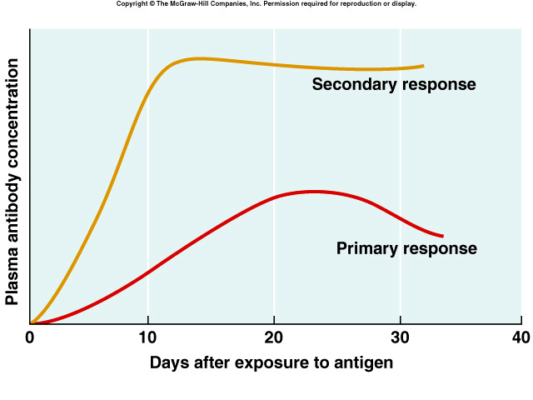

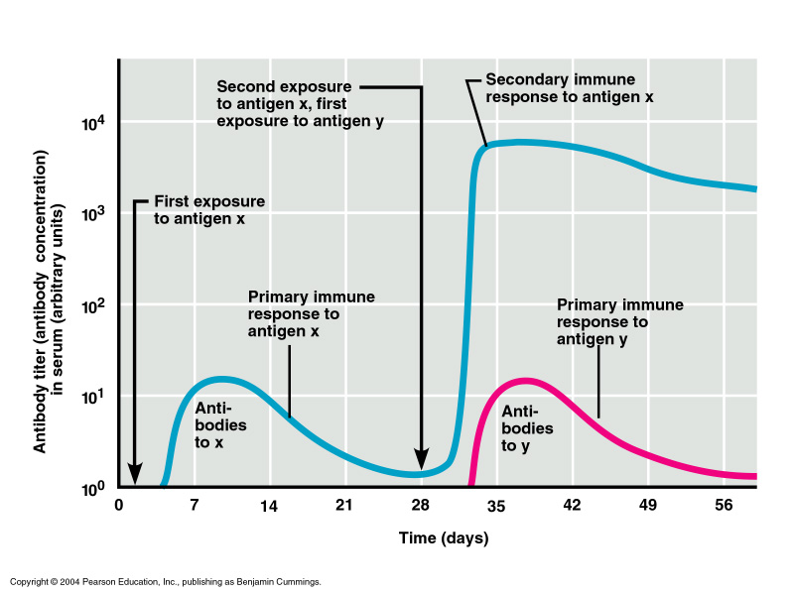

Vaccination Programs
- Large scale vaccination programs aim to eradicate a disease, eg. Smallpox
- Large scale vaccination increases the immunity of a population, preventing the spread of the disease, this is called herd immunity.
- With a large number of immune individuals, the risk of transmission between them is greatly reduced.
- It also reduced the risk of the disease being transmitted to those unable to receive the vaccine.
Risks and Ethical Concerns
- The manufacturing of the vaccine is considered unethical (use of mice brains, chicken and human embryos)
- Group exploitation – the testing of the vaccines on the poor
- Phobia
- Cost
- Unnatural

Antibiotics
- Antibiotics are drugs that are used to fight infections of micro-organisms, primarily bacteria.
- There are two types of antibiotics
- Bactericidal- these kill bacteria by changing the structure of by disrupting the action of essential enzymes.
- Bacteriostatic- These stop bacteria from reproducing, usually by disrupting protein synthesis.
- Some antibiotics affect a wide range of different types of bacteria. These are called broad spectrum antibiotics.
- Other antibiotics are effective only against specific bacteria, these are called narrow spectrum antibiotics.

Problems with antibiotics
- Due to the wide use of antibiotics problems have arisen
- Some bacteria have gradually evolved to become resistant to many types of antibiotics. This is known as multiple drug resistance. These strains of bacteria are often referred to as ‘super bags’ eg. MRSA
- Some bacterial strains are not beginning to show resistance to all know drugs, this is referred to as total drug resistance.

Antiviral Drugs
- Antiviral drugs are used specifically for treating viral infections.
- The way viruses reproduce make I difficult to find drugs that will treat viral infections.
- Because host cells produce new virus particles, any drug that interferes with viral replication is likely to be toxic to cells.
- With the increase in use of genetic sequencing research aims to develop chemicals that target specific viral proteins
- If these proteins are very different to human proteins, there should be few side effects.
- Unlike antibiotics that destroy pathogenic bacteria, antivirals inhibit the development of virus
- Examples of Viruses- Herpes; treated with Zovirax

MECHANISMS OF EVOLUTION

BIOTECHNOLOGY
DNA
- Deoxyribonucleic acid (DNA) is found in the nucleus of the cell.
- Sections of the DNA molecule contains genes, which determine genetic characteristics.
- Genes determine what proteins a cell can make by coding for particular sequence of amino acids.
- A number of genes together form a chromosome.
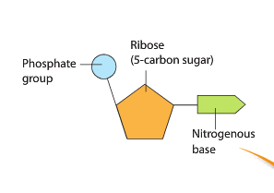
DNA Structure
- DNA – Deoxyribonucleic acid is a compound made up of thousands of nucleotides. Each nucleotide consists of:
  - ribose (5 carbon sugar)
  - A phosphate group
  - Nitrogenous base

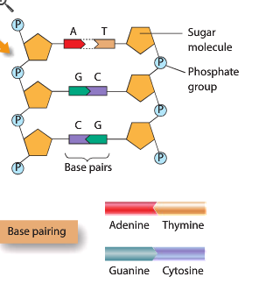
- Nucleotides are joined in such a way that alternating sugars and phosphates form two chains that are linked by the nitrogenous bases.
- There are four bases:
  - Adenine (A)
  - Thymine (T)
  - Cytosine (C)
  - Guanine (G)
Adenine will only pair with Thymine
Cytosine will only pair with Guanine

The two chains of altering sugars and phosphate, joined by the pairs, are twisted into a spiral shape known as a double helix

Human Genome
- A genome is the complete set of genetic information of an organism.
- For humans this is the complete sequence of the nucleotides that make up the 20000-25000 genes in our chromosomes.

Identification of hereditary disease
- A hereditary disease is caused by defective genetic information being transmitted from parents to children.
- At times a gene may change quite suddenly from its original structure to produce new characteristics, this is referred to as mutation.

DNA sequencing
DNA sequencing is determining the sequence of nucleotides along a DNA sample.
- The most common method of DNA sequencing is the Chain termination method of sequencing.
- This was developed by Frederick Sanger and is often referred to as Sanger sequencing.

Chain termination DNA sequencing
- The chain termination method of DNA sequencing consists of 4 main steps.
  - Strand separation
  - Primer annealing
  - Primer extension
  - Termination

Strand Separation
- DNA is a double stranded molecule.
- For sequencing to occur the two DNA strands need to be separated into the template strand and the complimentary strand.
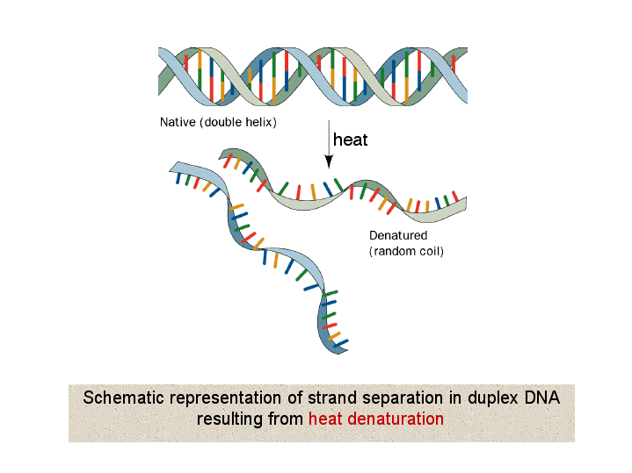
- This is done by heating the DNA.
Template strand
Complimentary strand

Primer Annealing
- To prepare the DNA for the next step a DNA primer needs to be added to the start of the template strand.
- The primer is a short strand of DNA with a complementary sequence to the start of template strand.
- The primer can be up to 25 nucleotides long.
- The DNA primer is required to allow DNA polymerase to perform the next step.
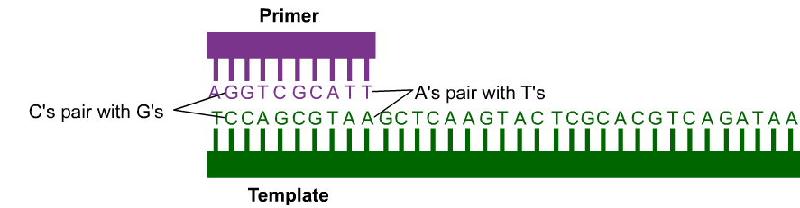
Primer Extension
- During this step free nucleotides are added with each of the four bases, along with DNA polymerase.
- DNA polymerase is a protein that reads the template strand and produces a new complementary strand 1 nucleotide at a time.
Chain Termination
- Dye-labeled dideoxynucleotides are added.
- Wherever these are incorporated into the new strand primer extension is terminated.
- This creates a mixture of DNA strands terminated at different lengths each colour coded by which of the 4 bases their last nucleotide was.
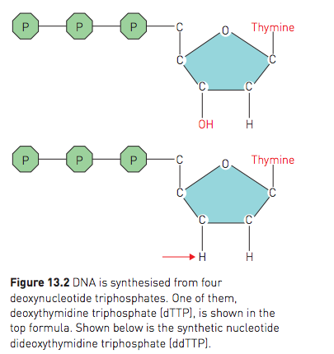
Dideoxynucleotides
- When building a strand of DNA the new nucleotide is bonded to the hydroxyl (OH) group of the previous nucleotide.
- The synthetic Dideoxynucleotides lack this OH group so no further nucleotides can be added.
- This stops elongation of the sequence. (terminating the chain at the point where ne synthetic nucleotide was added)

Capillary electrophoresis
- Just as with gel electrophoresis, DNA fragments are organised by length.
- Smaller fragments move through the capillary tube quicker than larger ones.
- As the fragments move through one at a time in size order they as through a laser which can read the dye labeled nucleotide at the end of each fragment.
- This gives a graphical readout of the colours detected in order and therefore the nucleotide base sequence of the DNA.

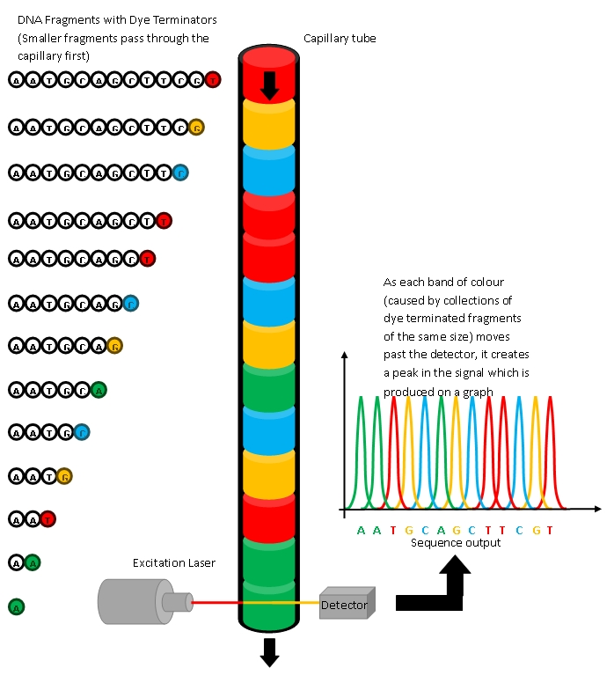

Uses of DNA sequencing
- DNA sequencing allows us to show whether an individual will develop an inherited disease.
- By comparing DNA sequences changed alleles can be detected.
- It also allows us to detect point mutations as well as small insertions or deletions.
- Identifying the faulty alleles for diseases such as Sickle cell anemia and cystic fibrosis allows for earlier treatment.
- DNA sequencing has also been used for maternity and paternity tests.

DNA Profiling techniques
- A persons DNA is so distinctive it can be used as a means of identification.
- Scientists have developed techniques using enzymes to cut DNA at specific base sequences, leaving pieces of various lengths.
- The length of these pieces varies from one person to another.

Electrophoresis
Electrophoresis is a technique used in DNA profiling
Steps
- Enzymes are used to cut the DNA at specific base sequences, leaving pieces at various lengths. (The lengths will vary in different people)
- DNA is placed at the negative end of the gel bed.
- An electric current passes through the gel.
- The negatively charged DNA moves towards the positive charge at the opposite end of the tank.
- The DNA pieces move through the gel at different speeds. Smaller pieces move faster than larger ones.
- This forms bands in the gel creating a DNA fingerprint that is unique to each person.

Polymerase chain reaction (PCR)
The PCR is a technique used to artificially multiply segments of DNA through a series of repeated cycles.

Steps involve
1. Denaturing (strand separaton)
2. Annealing or hybridisation
3. Synthesis/Extension
1. Denaturing - by the heating (94-98C) the doubles stranded DNA to separate the strands.

2. Annealing or hybridisation - Temperature is lowered (50-65C). A primer (small single strand of DNA) is added and binds to complementary base sequences on separated DNA indicating the section of DNA to be replicated. DNA is now annealed to the primer.

3. Synthesis or Primer extension – An enzyme DNA polymerase (Taq polymerase) attaches to the primer and replicates a new DNA stand by adding nucleotides. Segments of single stranded DNA are replicated/amplified through a repeated series of cycles.

Applications of PCR
- DNA profiling
- Medical research (mutations in genes)
- DNA amplification
- Fossil identification

Recombinant DNA Technology
Recombinant DNA technology involves the introduction into cells of DNA that is foreign to the organism. It can be used to take genes from one organism and place them into the chromosomes of another. It can be used in the diagnosis and treatment of diseases and genetic disorders.
Has the potential to allow faulty genes can be replaced with healthy ones.

The following process is usually used
(1) Isolate the gene required and cut it out using a restriction enzyme at a recognition site.
Restriction enzyme cuts DNA on either side of the gene required, producing a fragment that includes the gene. Sticky ends are produced at either ends of the fragment.

(2) From a bacterial cell, isolate a plasmid (circular strand of DNA) and cut out a segment with the same restriction enzyme used to remove the gene. Sticky end are produced at either ends of the fragment.

(3) Use ligase (DNA joining enzyme) to join the human gene (strand of DNA) to the plasmid DNA. Joins the sticky ends together.

(4) Return the plasmid to the bacterial cell and allow the bacteria to multiply (clone), multiplying/copying the gene.

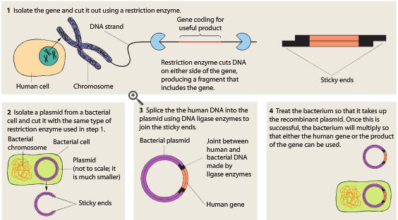

Examples of uses of recombinant DNA technology
People with type 1 diabetes have elevated blood sugar levels due to impaired insulin production by the pancreas.
Previously people suffering form this disease were treated with insulin derived from the pancreas of pigs and cattle.
In 1982 insulin produced by genetically engineered bacteria was approved.

Recombinant DNA technology (Insulin)
(1) A restriction enzyme is used to remove a functioning insulin gene from a DNA segment.

(2) A bacterial plasmid is removed and cut open using the same restriction enzyme.

(3) Ligase is used to insert the insulin gene into the plasmid (Bacterial DNA).

(4) The modified plasmid (DNA) is inserted back into Bacterium.

(5) Bacteria multiply and produce insulin.

(6) Insulin extracted and used in the treatment of Diabetes
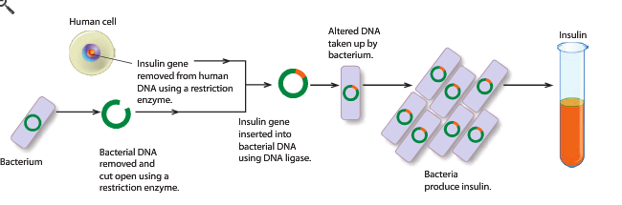

Gene Therapy
- The introduction of functioning genes into cells in place of missing or defective ones
- Most commonly, gene therapy uses a vector, typically a virus, to deliver a gene to the cells where it's needed. Once it's inside, the cell's gene-reading machinery uses the information in the gene to build RNA and protein molecules. The proteins (or RNA) can then carry out their job in the cells.
- While many disorders or medical conditions can potentially be treated using gene therapy, others are not suitable for this approach.

Treating diabetes mellitus with gene therapy
- In type 1 diabetes beta cells are destroyed by the immune system.
- Research in animal testing has shown that the genes responsible for detecting and producing insulin can be inserted into other cells in the liver (hepatocytes).
- These genes enable the hepatocytes to function fully as beta cells.

Gene Therapy Examples
Gene therapy is the introduction of normal genes into cells in place of missing or defective ones in order to correct genetic disorders.
Diseases that are treated are usually caused by single gene mutation.
Examples of its use include
- Cystic Fibrosis
- Huntington’s disease (in the research stage)

Cell replacement therapy
- Cell replacement therapy is the replacement of damaged cells with healthy ones
- Currently embryonic stems cells would be required for this research because they can differentiate into the required tissue. There are many ethical concerns about experimentation of human embryos. However, recent research is being done into looking at reprograming adult stem cells so they can differentiate into required tissue types this would remove those concerns.
Cell replacement therapy and the CNS
- Research is being conducted on cell replacement therapy for the nervous system in particular the replacement of dying neurons with healthy ones in patients with Parkinson's disease

Parkinson’s and Alzheimer’s
- Parkinson’s disease is caused by the progressive degeneration of nerve cells in the middle area of the brain. This causes a lack of dopamine, a chemical messenger necessary for smooth, controlled movements.
  - Some of the main symptoms are:
  - Tremor (shaking)
  - Rigidity (muscle stiffness)
  - Bradykinesia (slowness of movement)
  - Freezing
  - Stooped posture
  - Shuffling gait
  - Micrographia (small handwriting)
  - Lethargy.
- Alzheimer’s disease is caused by the progressive degeneration of nerve cells in the cerebral cortex of the brain.
- It affects memory, thinking skills, emotions, behaviour and mood. As a result, a person’s ability to carry out daily activities becomes impaired

Cell replacement therapy to treat Parkinson’s and Alzheimer’s
- Embryonic stem cells have been used to replace dying neurons involved with these conditions with healthy neuronal tissue.
- Transplanted cells have been shown to survive and to successfully establish functional connections with adjacent neurons.
- Use of embryonic stem cells raises many ethical issues. Researchers are looking for other sources of cells to help restore brain function

MUTATIONS AND GENE POOLS
Curriculum Links
Mutations
- mutations in genes and chromosomes can result from errors in DNA replication, cell division or from damage caused by mutagens.
- different genotypes produce a variety of phenotypes, which are acted on differently by factors in the environment, producing different rates of survival.
- mutations are the ultimate source of variation introducing new alleles into a population: new alleles may be favourable or unfavourable to survival.

Gene pools
- populations can be represented as gene pools that reflect the frequency of alleles of a particular gene; gene pools can be used to compare populations at different times or locations
- gene pools are dynamic, with changes in allele frequency caused by:
  - mutations
  - differing selection pressures
  - random genetic drift, including the founder effect
  - changes in gene flow between adjoining groups
- the incidence of genetic diseases in particular populations illustrates the effects of different factors on the dynamics of gene pools, including the incidence of Tay-Sachs disease, thalassemia and sickle-cell anaemia
- natural selection occurs when factors in the environment confer a selective advantage on specific phenotypes to enhance survival and reproduction
- the mechanisms underpinning the theory of evolution by natural selection include inherited variation, struggle for existence, isolation and differential selection, producing changes to gene pools to such an extent that speciation occurs

Changes to allele frequencies
- Mutations
- Natural selection
- Random genetic drift including the founder effect
- Migration

Mutations
- Occur suddenly and by chance.
- Gene mutation = change in a single gene
- Chromosomal mutation = all or part of a chromosome is affected.

Mutagens
- Increase the rate of mutations
  - E.g. Radiation, Formaldehyde, x-rays

Somatic vs. Germline Mutations
- Somatic Mutation: A change occurring in a gene in a body cell (not in gametes). It can only affect the individual.
- Germline Mutation: A change in the hereditary material of an individual (in the gametes). This may then be passed on to other generations.

Effects of Mutations – Gene Mutations
Point Mutations
- Change in just one base.
- Can alter proteins or prevent proteins from being produced.
- E.g.
    - Albanism
    - Duchenne Muscular Dystrophy
    - Cystic Fibrosis

Lethal Recessives
- Can cause death of embryo/foetus
- Tay-Sachs Disease (TSD)
- Baby with two recessive alleles develops normally then deteriorates with mental and physical disabilities, death usually occurs in early childhood.

Chromosomal Mutations
- Deletion – part of the chromosome is lost.
- Duplication – section of chromosome occurs twice.
- Inversion – DNA breaks and the pieces are re-joined in the wrong order, this can disrupt meiosis.
- Translocation – Part of the chromosome breaks off and is re-joined to the wrong chromosome.
- Non-Disjunction – During meiosis chromosome pairs don’t separate.

Effects of Mutations – Chromosomal Mutations
Down Syndrome
  - Non-disjunction
  - Individual has three copies of chromosome 21
Patau Syndrome
  - Non-disjunction
  - Individual has an extra copy of chromosome 13
  - Symptoms: Mental retardation, small head, malformations in the eyes and ears.
Trisomy 16
  - Non-disjunction
  - Most common trisomy. (occurs in 1% of pregnancies)
  - Usually results in spontaneous miscarriage.

Klinefelter’s Syndrome (XXY)
  - Non-disjunction
  - Individuals have small testes and do not produce sperm.
  - Mental retardation.

Monosomy – missing a chromosome, Deletion.
Cri-du-chat Syndrome
  - Missing a portion of chromosome 5.
  - Problems with the larynx and nervous system.
Turners Syndrome
  - Individuals only have one X chromosome.
  - Lack secondary sexual characteristics and are infertile.

- When autosome chromosome is missing completely usually leads to severe malformations and miscarriage.

EVOLUTIONARY MECHANISMS
Curriculum Links

Gene pools
- gene pools are dynamic, with changes in allele frequency caused by:
  - mutations
  - differing selection pressures
  - random genetic drift, including the founder effect
  - changes in gene flow between adjoining groups
- the incidence of genetic diseases in particular populations illustrates the effects of different factors on the dynamics of gene pools, including the incidence of Tay-Sachs disease, thalassemia and sickle-cell anaemia
- natural selection occurs when factors in the environment confer a selective advantage on specific phenotypes to enhance survival and reproduction
- the mechanisms underpinning the theory of evolution by natural selection include inherited variation, struggle for existence, isolation and differential selection, producing changes to gene pools to such an extent that speciation occurs

Evolution
The statistical change in allele frequency of a gene pool of a population over time.

Changes to allele frequencies can be due to a number of factors
- Natural Selection
- Random Genetic Drift and Founder Effect
- Migration

Alleles
- An alternative form of a gene
- In some cases there are only two alternative forms of a gene (alleles). An example of this can be seen in the study of earlobes. A persons earlobes can be free or attached. Thus there are two forms of alleles that determine the shape of earlobes.
- Sometime there are more than two alleles for a particular characteristic – these are called multiple alleles. An examples is ABO blood group. There are three alleles that code for this trait by we only possess two of them A, AB, B or 0

Monogenic inheritance
- Monogenetic inheritance is a type of inheritance that is controlled by only one pair of alleles
- Example: blood groups , there are three different alleles that control blood group ABO, however an individual has either the blood group A, AB,B or O. Thus only one pair of alleles in each individual for the characteristic
- Monogenetic inheritance produces little variation between individuals

Polygenic inheritance
- Polygenic traits are determined by more than one pair of genes.
- Polygenic phenotypes exhibit continuous variation, since each different gene pair results in just a small phenotypic change.
- This can result in a range of phenotypes

Evolution through natural selection
Evolution is generally a slow process over many years. It normally results in organisms being better suited to their environment. The greatest driver of evolution is natural selection.
Natural selection involves a number of steps:
- Variation
- Competition
- Selection
- Reproduction

Principles involved in evolution/natural selection
Variation: Each individuals of a species differs slightly in behaviour, structure and function (due to independent assortment, sexual reproduction, gene mutations, chromosome mutations)
Competition: A population produces more offspring than can survive and reproduce. This produces competition between individuals for limited resources or competition for survival against and environmental factor. .
Selection: Individuals with variations that are better suited to a particular environment have a better chance of surviving.
Reproduction: Successful individuals with favourable characteristics reproduce with similar individuals and pass the genes for these characteristics onto their offspring. This increases the number of favourable genes in the population thus changing the gene frequency.

Evolution common misconception
The most common misconception about evolution is that an individual changes over their life time to suit their environment. When an organism is produced they have a set genetic make up and cannot change. What can happen is that when organisms produce offspring these offspring show variation and the offspring that are best suited to the environment will have a greater chance of surviving.

Natural Selection (skin colour)
Variation: The original population has variation in skin colour from light to dark. This variation would be due to mutations that were heritable.
Competition: In an environment with high levels of U.V. radiation (selection pressure) competition for survival takes place with dark skin colour being the selective advantage.
Selection: Dark skinned individuals are less likely to burn and less likely to get skin cancer therefore have greater chance of survival. Light skin individuals are less likely to survive as they are at increased risk of skin cancer.
Reproduction: Dark skinned individuals reproduce together increasing the number of dark skinned individuals. Over time this changes the allele frequency of the population.

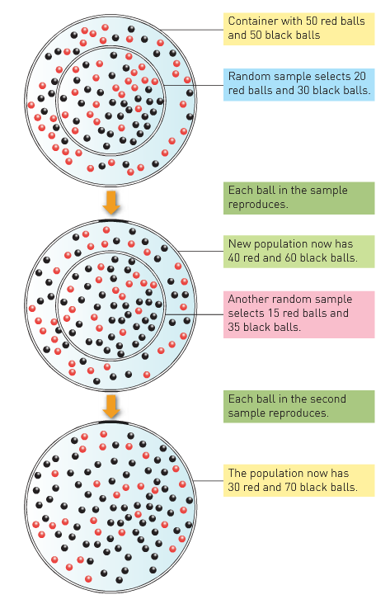
Random Genetic Drift
- In general, the gene frequencies of a large population do not change from one generation to the next unless natural selection favours or removes particular genes.
- In small populations a change in a gene frequency may occur by chance (i.e. a random, non-directional change) due to the small size of the population.
- Studies have been done on isolated groups to demonstrate this effect. An example is the Dunkers, a small German group from a area called Hesse that lived and breed in the USA in isolation from the general population. They show statistical variation in traits such as blood group, ears lobes and L/R handedness from the present day population of Hesse and surrounding American population.

Founder effect
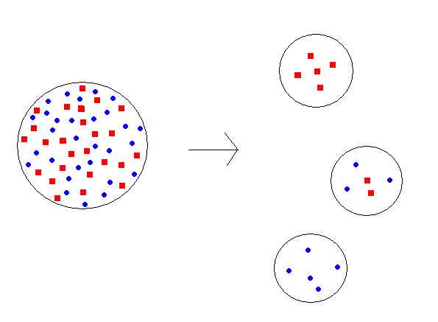
A type of genetic drift that occurs when a small sample of a large population can becomes isolated, having migrated to a new area.
This small samples allele frequency does not always represent that of the original population.
On some occasions, due to small initial gene pool some gene frequencies become more prevalent in the population as it increases in size in comparison with the original population. This is called the founder effect.

Migration
- Gene flow from one population to another.
- For example if immigrants to a certain country bring alleles that are not already in the population, the frequencies for the alleles will be altered.
- Example: original Chinese population had only Rh positive antigen. When European countires began trading with China immigrants and sailors introduced the Rh negative allele. However the frequency of the Rh negative allele is still low in China compared to other countries.

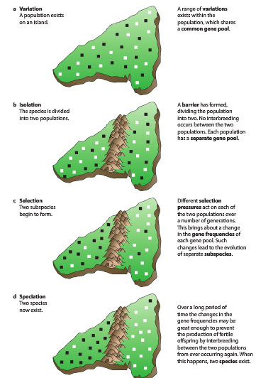
Barries to Gene Flow
- Geographical barriers
  - Oceans
  - Mountains ranges
  - Expansive Ice Sheets
- Sociocultural Barriers
  - Religion
  - Language
  - Economic Status
Speciation
- If two populations are isolated for a very long period of time, and the environmental influences on each are different enough, major changes in the allele frequencies within each population could occur.
- In such a situation, the members of those populations may become so different that, even if the barriers to reproduction were removed, interbreeding would no longer be possible.
- If this occurred, the two populations would be regarded as separate species. The process of producing two species in this way is referred to as speciation.

Natural selection and genetic disease
- Genetic diseases may result in changes to allele frequencies in a gene pool. An allele causing an inherited, fatal disease would be expected to be gradually eliminated from a population because people with the allele would die and would not pass it on to the next generation.

Genetic Diseases
Tay-Sachs Disease
  - Occurs most frequently in individuals of Jewish descent from Eastern Europe.
  - Frequency worldwide is very low but high in Jewish populations.
  - Possible reasons: Genetic drift, Heterozygotes have increase resistance to tuberculosis (TB).
Thalassaemia
  - Recessive disease causing anaemia.
  - High rates in the Mediterranean especially from Italy or Greece.
  - May be due to high proportion of marriage of cousins in small populations. Possible random genetic drift.
Sickle-Cell Anaemia
  - Occurs mainly in Black Africans or people of African descent.
  - Fatal.
  - Heterozygous advantage – provides partial immunity to Malaria.
Sickle-cell anaemia occurs when the red blood cells have an abnormal crescent or sickle shape. It is usually lethal for the homozygous sickle, because the sickled red blood cells clump together causing organ damage, decreasing life expectancy.

Having one allele for sickle-cell anaemia (heterozygous sickle) is selectively advantageous because it provides malaria resistance. Thus increasing the frequency of sickle-cell amaemia among populations were malaria is in high prevalence.
Advantages of having sickle-cell trait
- Malarial resistance
Disadvantages of having sickle-cell trait
- Red cells sickle when oxygen concentration is low
- Complications from sickled cells

EVIDENCE OF EVOLUATION

Evidence of evolution
To support the theory of evolution we can draw on observations and evidence from the following:
- Fossils
- Comparative studies of DNA
- Comparative studies of proteins
- Anatomy
- Comparative embryology
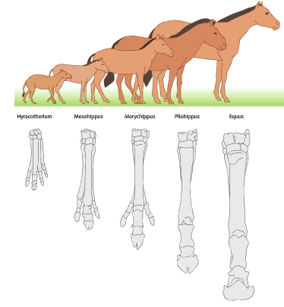
Fossils
- Fossils of extinct organisms (particularly bones) enable scientists to follow the evolution of organisms by tracing structural similarities back to a common ancestor.
- Fossils can also show similarities between past and present organisms.
- Fossils can also show a sequence of evolution of a particular organism over time
  - E.g. We have the complete fossil record of the evolution of the horse.
- However fossil record is often incomplete and open to a variety of interpretations.

Comparative studies of DNA sequences
- The study of DNA sequences can be used to compare evolutionary relationships.
- All living things have the same nitrogenous bases (adenine, cytosine, guanine and thymine) suggesting all living things evolved from a common ancestor with those bases.
- The only thing that varies is the sequence of those bases, the more similar the DNA sequence the more closely related the species under consideration.

Comparative studies of DNA sequences
- There are two types of DNA that are sequenced and analysed to show evolutionary relationships:
  - Genomic/nuclear DNA (in the Nucleus)
  - Mitochondrial DNA (in the Mitochondria)

Mitochondrial DNA
- Most of a cells DNA is located in the nucleus but a small amount is in the mitochondria.
- This is called mitochondrial DNA (mtDNA)
- Most cells contain many mitochondria and therefore have a large numbers of the mitochondrial DNA molecules (mtDNA).
  - This makes it easier to find and extract than the DNA of the nucleus allowing smaller samples to be used.
- mtDNA is inherited only from the mother. Scientists are able to use the similarity between the mtDNA of any two individuals to help estimate of the closeness of their relationships through their material ancestors (mothers).
- mtDNA is inherited only from the mother.
- mtDNA has a higher rate of mutation. This is proportional to the amount of time that has passed. (Longer time-more mutations/differences)
- Scientists are able to use the difference between the mtDNA of any two individuals to help estimate of the closeness of their relationships through their material ancestors (mothers).
  - The more similar, the more recent the common ancestor.

Comparative Protein studies
- By determining the type and sequence of amino acids that make up proteins, scientists can compare evolutionary relationships between species.
- Species that are more closely related have more similar amino acid sequence. (Order and types of amino acids that make up the protein)
- When using comparative protein analysis Ubiquitous proteins are used.
- These are proteins found in all organisms and all types of cells.(Cytochrome C)

Bioinformatics
- Bioinformatics refers to the use of computers to describe the molecular components of living things (DNA and protein molecules).
- Proteins and DNA are very large molecules. Therefore their comparisons are complex. Computers help analyse similarities and differences between these complex molecules quickly.
- We can use DNA sequencing and computers to compare the entire genomes of species (Comparative Genomics).

Comparative studies of Anatomy
- Comparative anatomy involves comparing the structural features of related animals to ascertain the degree of similarity between them.
- Similarities in structure often suggest that species have a common ancestor with that structure.
- There are three areas of focus within comparative studies of anatomy:
  - Embryology
  - Homologous organs
  - Vestigial Organs
Comparative Anatomy- Embryology
  - By comparing the development of organisms at the embryonic stage scientists can show that many organisms, particularly vertebrates have many structural similarities (at the embryonic level)
  - This suggests that they shared a common ancestor with this embryonic development.

Comparative Anatomy- Homologous organs
  - Many organisms have organs/structures that are similar is structure but different in function.
  - E.g. the human hand, whale flipper, and the wing of a bat have similar bone structure suggesting a common ancestor/origin with that structures
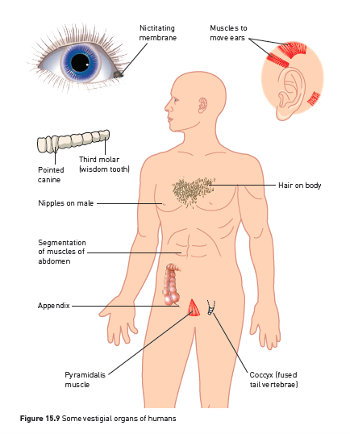
  - However these organs/structures have evolved over time to have vastly different functions.

Comparative Anatomy- Vestigial organs
  - Many organisms have organs that are reduced in size and have no apparent function.
  - In humans these include the appendix, coccyx, muscles to move ears etc.
  - These are remains of organs that were function in ancestral forms but have become redundant over time. They are evidence for evolution supporting the idea that organisms are changing over time.

Phylogenetic trees
- Evolutionary relationships can be shown using phylogenetic trees.
- These follow a branching pattern. The end of each branch represents an organism.
- Each branching point represents a common ancestor.
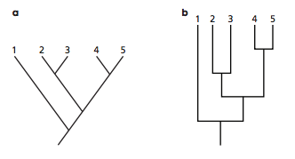
Phylogenetic trees can be displayed differently. These are two possible ways to display the same information

Geographical Distribution
- Darwins finches
- Isolated areas show distinct species.

ADAPTATIONS TO BIPEDALISM

Hominins vs Hominids
- Hominids include the great apes (Orangutans, Gorillas and Chimpanzees) and humans.
- Hominins include Humans and their fossil ancestors.
- Two main features that separate Hominins from the apes is that:
  - They are relatively hairless.
  - They are fully bipedal (walk on two legs with their forelimbs free)

Bipedalism vs Quadrupedalism
- It is the method of locomotion that sets Hominins apart from the other Hominids (Apes).
- Humans are fully bipedal where apes are quadrupedal knuckle walkers.
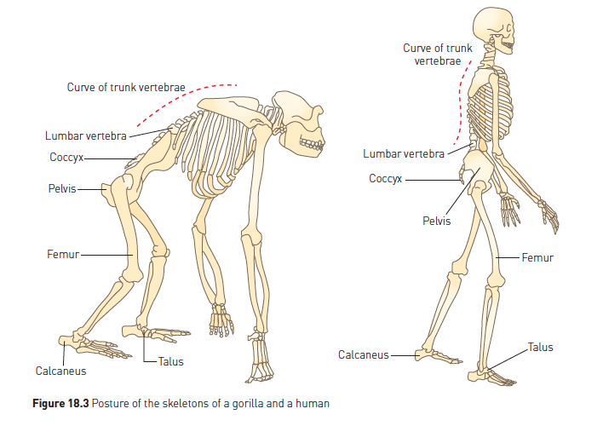
Adaptations for Bipedalism
- Hominins have many adaptations compared to apes that enable them to have bipedal locomotion. These include adaptations to:
  - Skull
  - Vertebral column
  - Pelvis
  - Femur
  - Knee
  - Foot
  - Arm to leg ratio
  - Centre of gravity

Adaptations for bipedalism- Skull
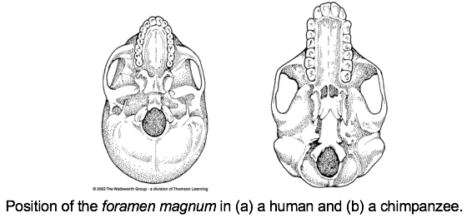
The foramen magnum is more central
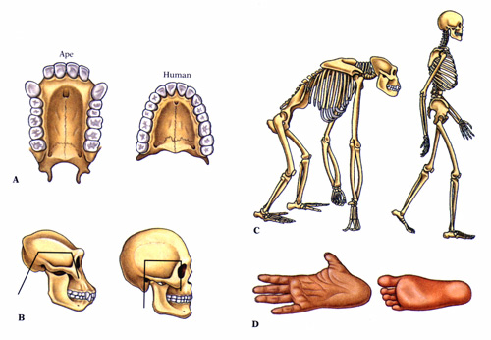
The Face is less prognathic (flatter)

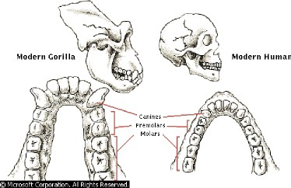
Smaller lighter jaw

Ape | Human (hominin)
- Foramen magnum at the back of the base of the skull  - More Prognathic (Jaw protruding more)  - Heavy U shaped jaw with large canines with diastema. | - Foramen magnum at the centre of the base of the skull  - Flatter face (less prognathic)  - Lighter horseshoe shaped jaw with smaller canines with no diastema.
Advantage to the Hominin
- Allows the skull to balance on the vertebral column with little effort.
- This reduces the requirement for large neck muscles.

Adaptations for bipedalism- Vertebral column

Ape | Human (hominin)
- Single curve C shape  - Non wedge shaped lumbar vertebrae  - Large processes on neck vertebrae | - S shaped curve  - Wedge shaped lumber vertebrae  - Small processes on neck vertebrae
Advantage to the Hominin
- Allows for centre of gravity to pass through the knee and foot. Skull can balance on the column with little muscle support.
- Forms lumbar curve to help balance body
- Allows for increased neck movement.

Adaptations for bipedalism- Pelvis
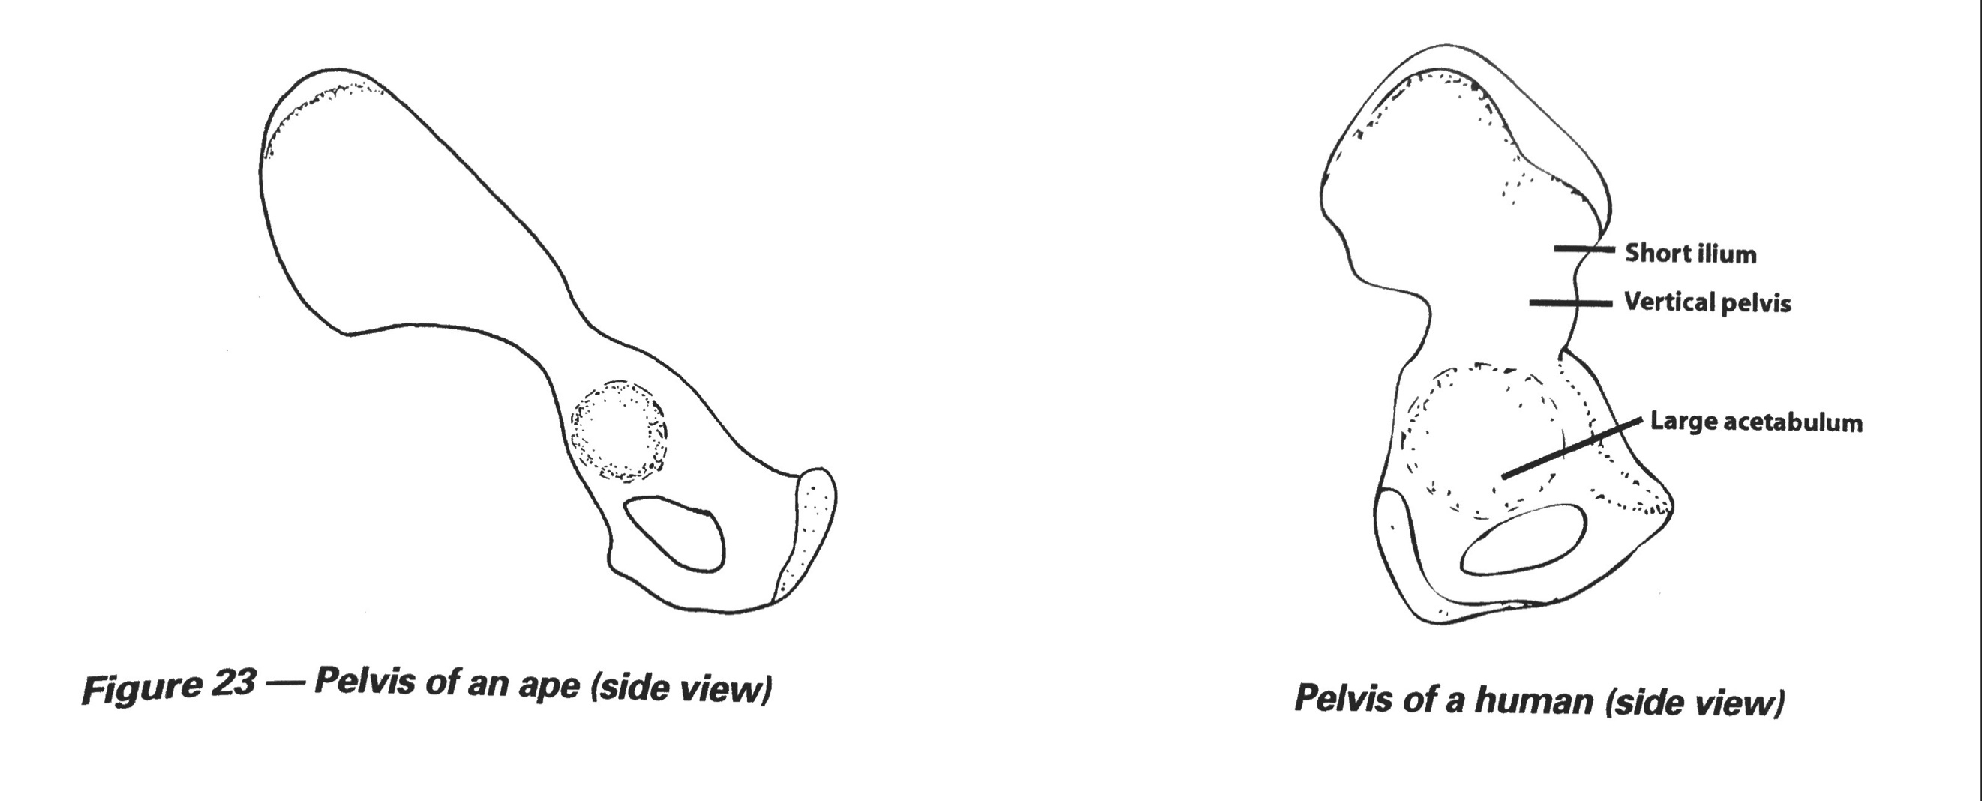
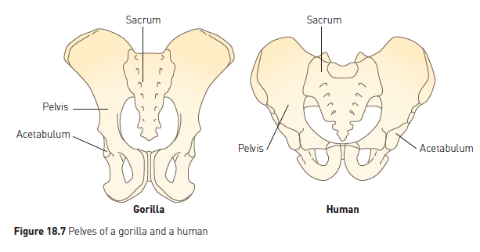

Ape | Human (hominin)
- Long and narrow and tilted forward | - Short, broad, bowl shaped and vertical.
Advantage to the Hominin
- Short and broad pelvis provides surface for attachment of leg muscles, This allows for movement of the legs while keeping the upper body erect.
- Bowl shaped to support abdominal organs (supports developing foetus during pregnancy)
- Vertical angle allows alignment with upright vertebral column.

Adaptations for bipedalism- Femur
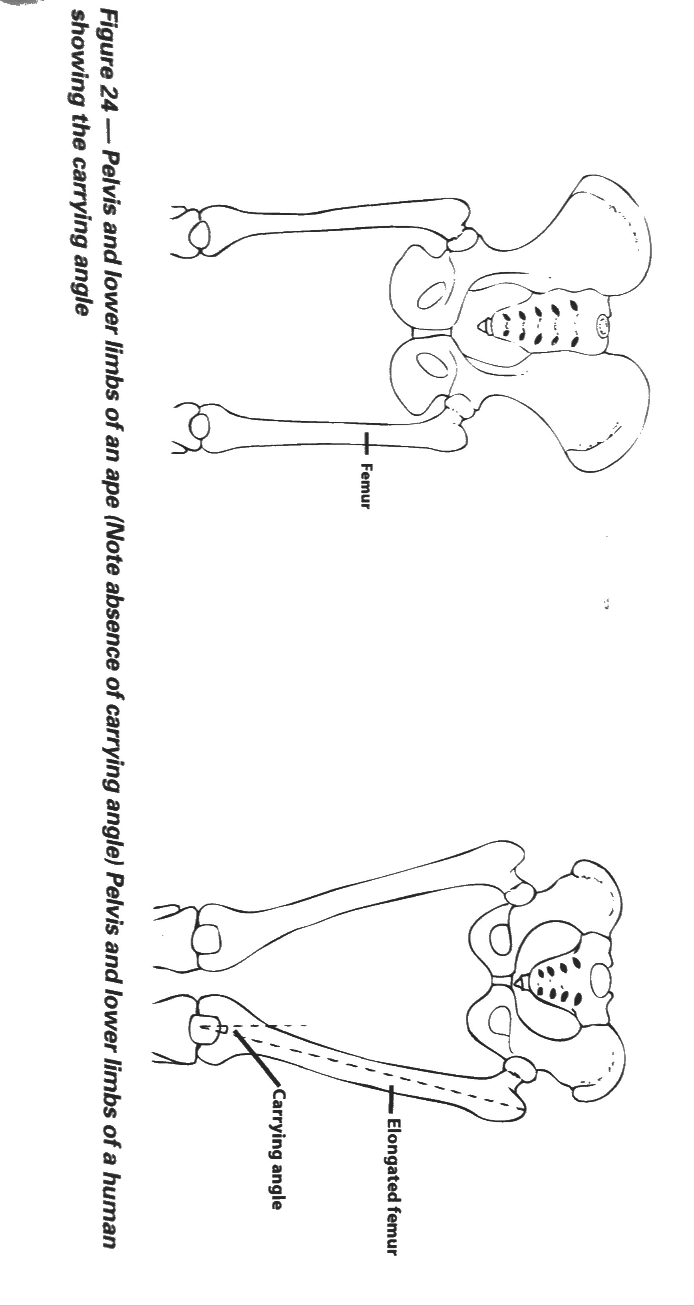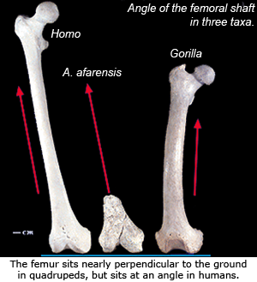

Ape | Human (hominin)
- Femurs come straight down from pelvis  - Shorter femur | - Modified acetabulum and longer ball shaft on femur.  - Femurs angle in from pelvis  - Longer femur  - Femur is more robust
Advantage to the Hominin
- This creates a carrying angle and brings the knees closer together. Thus it is easier to transfer weight from one foot to another when walking. This allows humans to have a striding gait instead of swaying from side to side.
- Allows for a longer stride

Adaptations for bipedalism- Knee
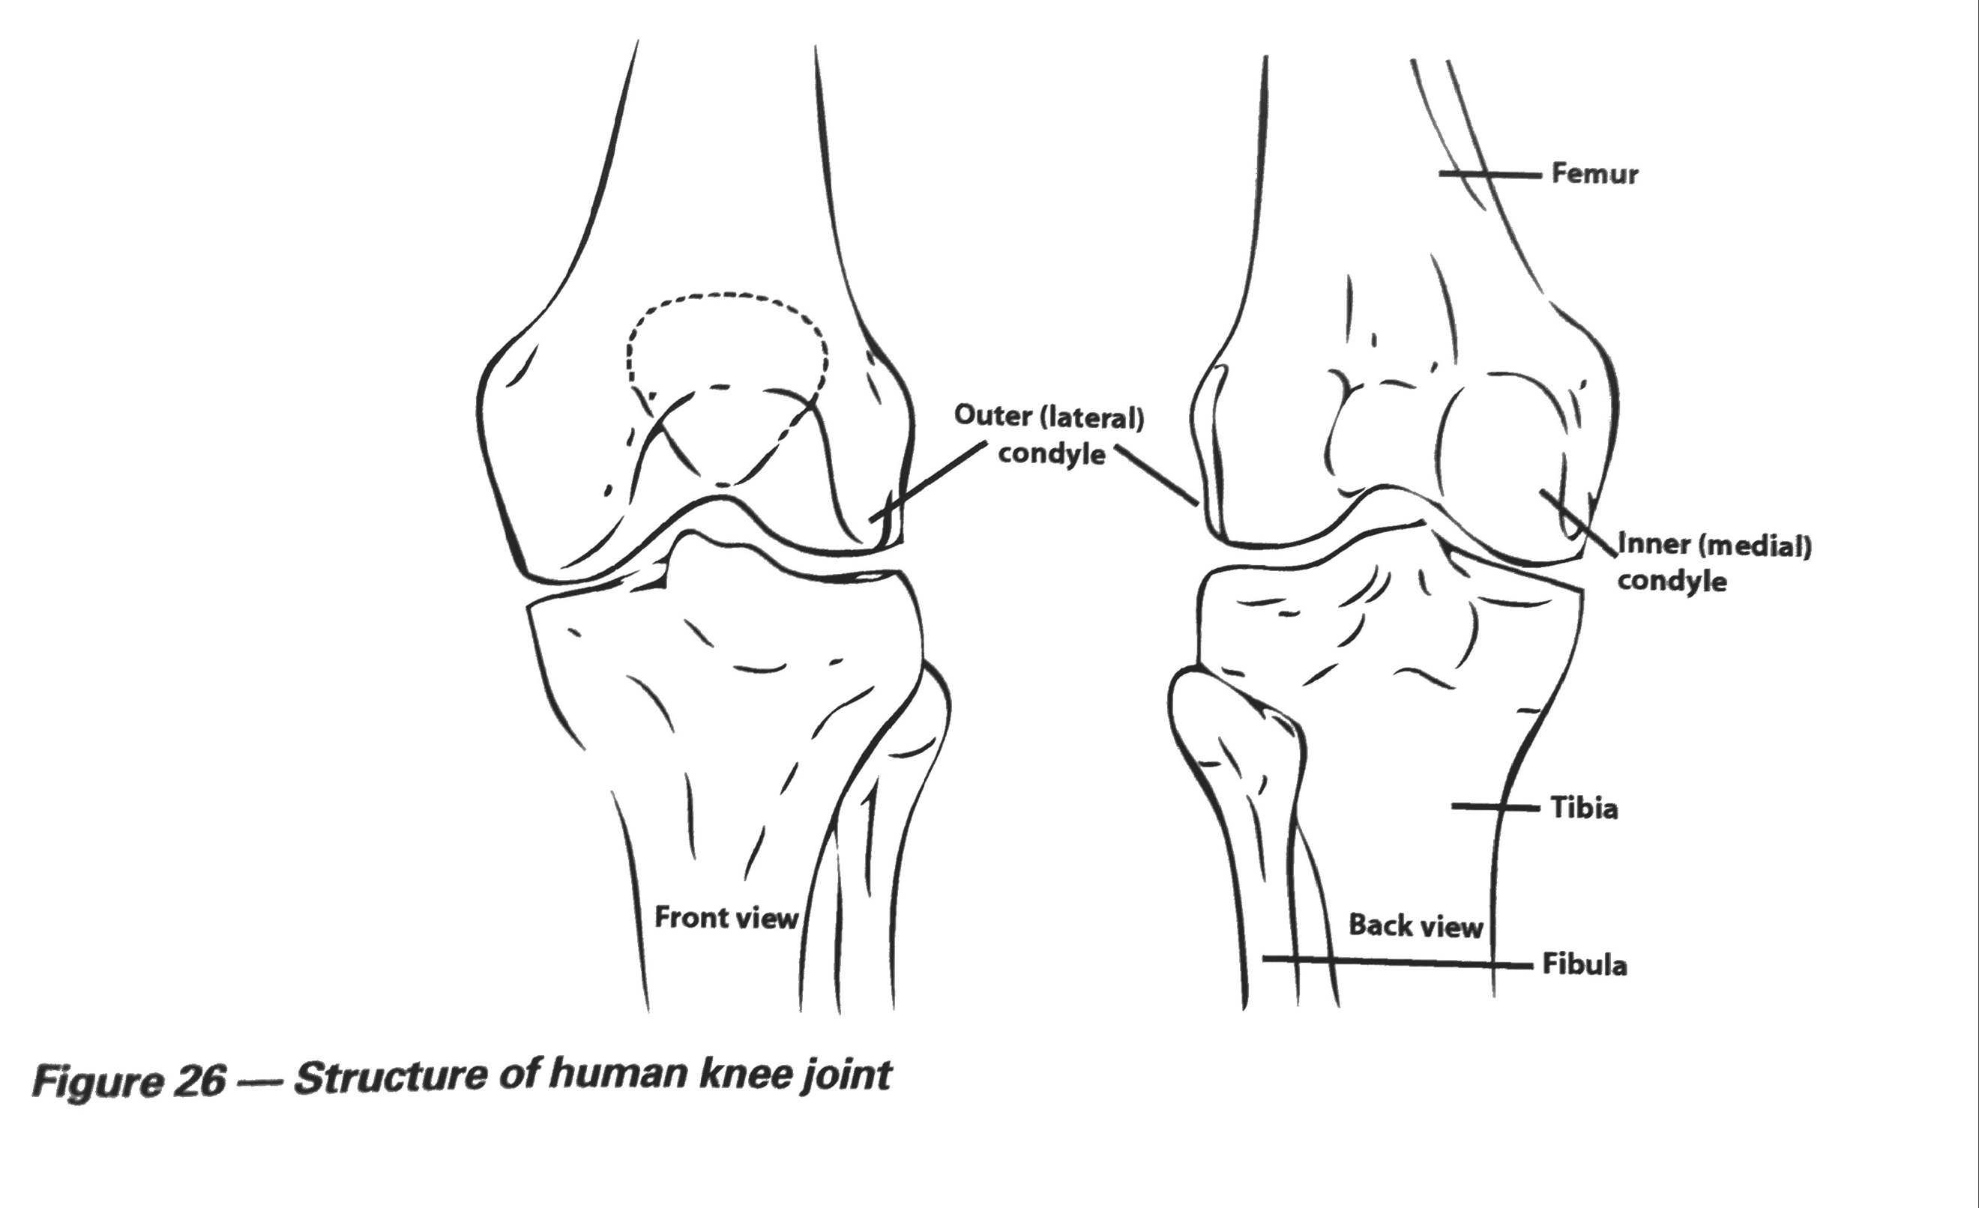
Ape | Human (hominin)
- Single hinge | - Two part robust hinge joint with ligaments
Advantage to the Hominin
- Robust (Load bearing)
- Centre of gravity falls in front of the knee. This forces knee backwards but is stopped by ligaments. Little energy is required for the standing position.
Adaptations for bipedalism- Foot
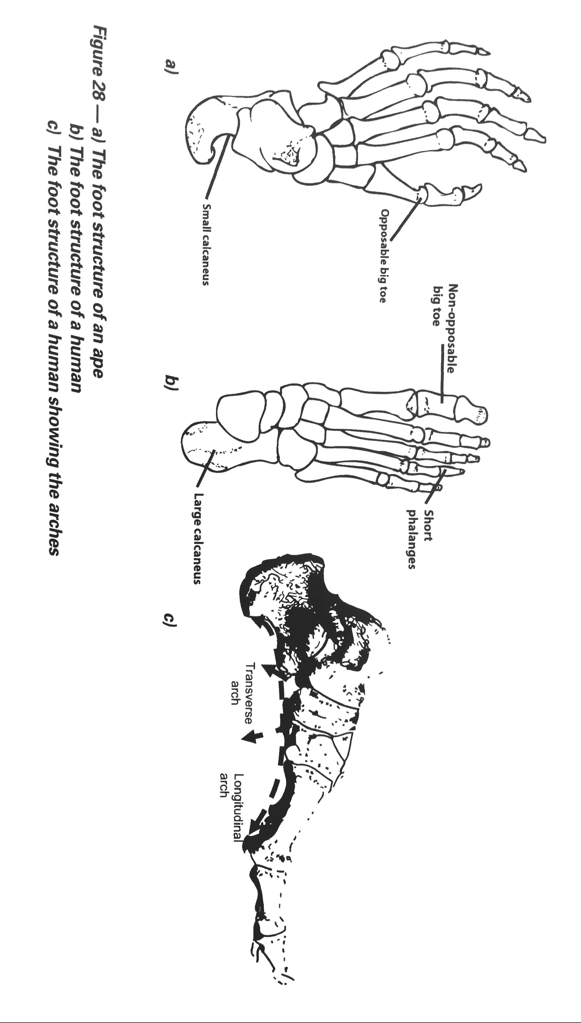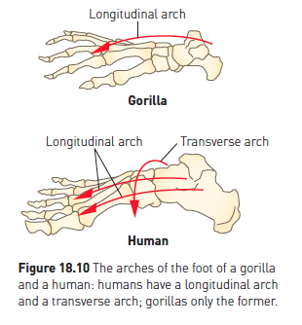

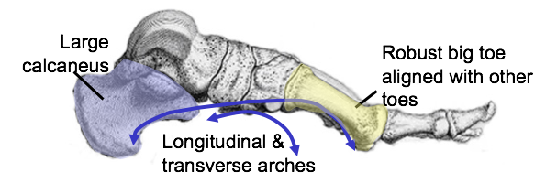

Ape | Human (hominin)
- Longitudinal arch  - Opposable big toe  - Small calcaneus | - Longitudinal and transverse arch  - Large big toe with it alongside others  - Large robust calcaneus
Advantage to the Hominin
- Produces a spring action and acts as a shock absorber when walking
- Acts to give a push off (lever) when walking as energy is transferred through it.
- Bears impact of bodies weight (load bearing)

Adaptations for bipedalism- Arm to leg ratio

Ape | Human (hominin)
- Arm longer than legs.  - Centre of gravity is higher within the body (Chest level) | - Legs longer than arms.  - Centre of gravity is lower within the body (Located in the pelvis)
Advantage to the Hominin
- Allows long striding gait.
- Increases stability whilst bipedal and ability to stand upright.

Adaptations for bipedalism- Centre of gravity

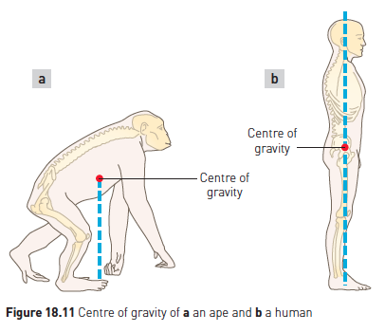
Ape | Human (hominin)
- Centre of gravity falls in front of the knee and feet  - Centre of gravity is higher within the body (Located above the pelvis) | - Centre of gravity falls through the front of the knee and the centre of the feet  - Centre of gravity is lower within the body (Located in the pelvis)
Advantage to the Hominin
- Increases stability whilst bipedal and ability to stand upright.
- Upright stance is achieved with minimal effort.

HOMONINS – THE HUMAN JIGSAW

The Hominin fossil record
- Most of the evidence we have of our early ancestry comes from fossils.
- These fossils are very rare, and often comprise of no more than a few broken fragments of heavily mineralised bone, or a few teeth. Very occasionally an almost complete skeleton or skull is discovered, but this is very unusual.
- Recognising our evolutionary history is like trying to piece together a jigsaw puzzle, with many of the pieces missing. Without a clear idea of the picture we can only infer how the puzzle might fit together.
- To date the total amount of fossil material discovered could be loaded into a small truck. Knowledge of our possible ancestry has been further aided by the study of DNA.
- Slowly the puzzle takes shape. However the picture is still far from complete and reconstructing our evolutionary history still remains one of the most challenging and controversial areas of science.

What is a Hominin?
- Hominins have the ability to stand upright with bipedal locomotion
- Hominins also tend to have:
  - a large brain
  - less hair

Why did bipedalism develop?
Where Hominins first appeared in East Africa there was a change in the climate and it became a cooler and drier.
This lead to a change in the vegetation from dense forest to open woodland and savannah.
Food in a savannah environment is different and more spread out than in a forest.
As a result Hominin ancestors must have had to expand their diet to include a greater variety of foods found on the ground (bulbs, grains, roots). Therefore they were forced to travel further from their home base to gather food.

What is the advantage in being bipedal?
- Bipedalism is an energy efficient means of covering large distances to collect food.
- It leaves the hands free to carry food, tools, weapons and young.
- Hominins stand taller so they have greater vision to spot food and or danger.
- Standing taller also increases ability to reach food.
- It allows an individual to appear larger, this deters predators.
- Less surface area is facing the sun in hot dry environments so they do not heat up as much.
- Body higher from ground minimises heat gain from the ground.
Given efficient bipedal locomotion, good eyesight, a smart brain and free hands, early bipeds (Hominins) had a better chance of surviving in a very challenging savannah environment than Quadrupeds (non Hominins).

Hominin ancestors
- Apes and humans share a common ancestor, an ape-like creature.
- From that ancestral ape the first hominins (modern and extinct humans) evolved.
- These were the Australopithecines classified in the genus Australopithecus
- It is believed that from one or more of the australopithecine species evolved early member of the genus Homo
- Species of early Homo gradually evolved into a number of different species including Homo habilis, Homo erectus and Homo neanderthalensis, and eventually into modern humans, Homo sapiens

Living and Fossil Hominins
  - Australopithecus afarensis (4-3 mya)
  - Australopithecus africanus (3.3-2.5 mya)
  - Paranthropus robustus (2.3-1 mya)
  - Homo habilis (2.3-1.8 mya)
- Homo erectus (1.9mya – 50,000 years ago)
- Homo neanderthalensis (350,000- 25,000)
- Homo sapiens (195,000 to present)

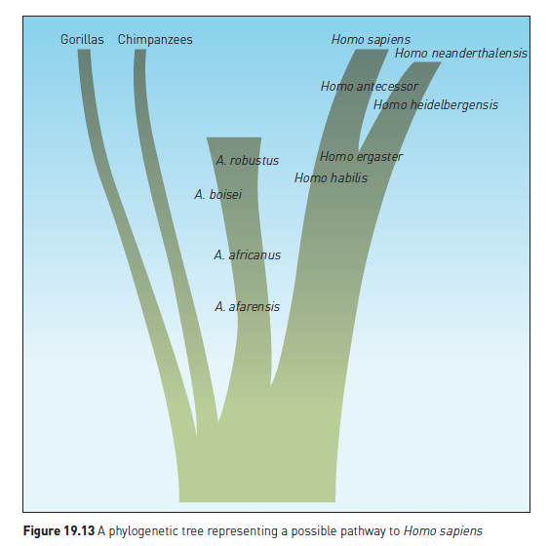

Australopithecus/ Paranthropus
- The Australopithecines where thought to be the first hominins. (Southern Africa)
- There were two forms, Gracile and Robust.
- The gracile forms were smaller & lighter and the robust were heavier.
- This lead to a reclassification with the two gracile forms being:
  - Australopithecus afarensis
  - Australopithecus africanus
- The robust forms being
  - Paranthropus robustus

Australopithecus Afarensis
Geographical Location: East Africa (Ethiopia, Tanzania)
Time period: 4 to 3 million years
Cranial capacity: av 430cm³ (small)
Height: 1-1.5m (Short)
Weight: 30-55 Kg (Light)
Skull/Jaw: Small cranial capacity (av 430cm³)Large brow ridges, low forehead, flared zygomatic arch.
Jaw: Prognathic jaw, large canines, diastema.
Locomotion: Bipedal: central foramen magnum, all post cranial adaptations to bipedalism (spine, pelvis, femur, knee, foot)
Culture: Not required
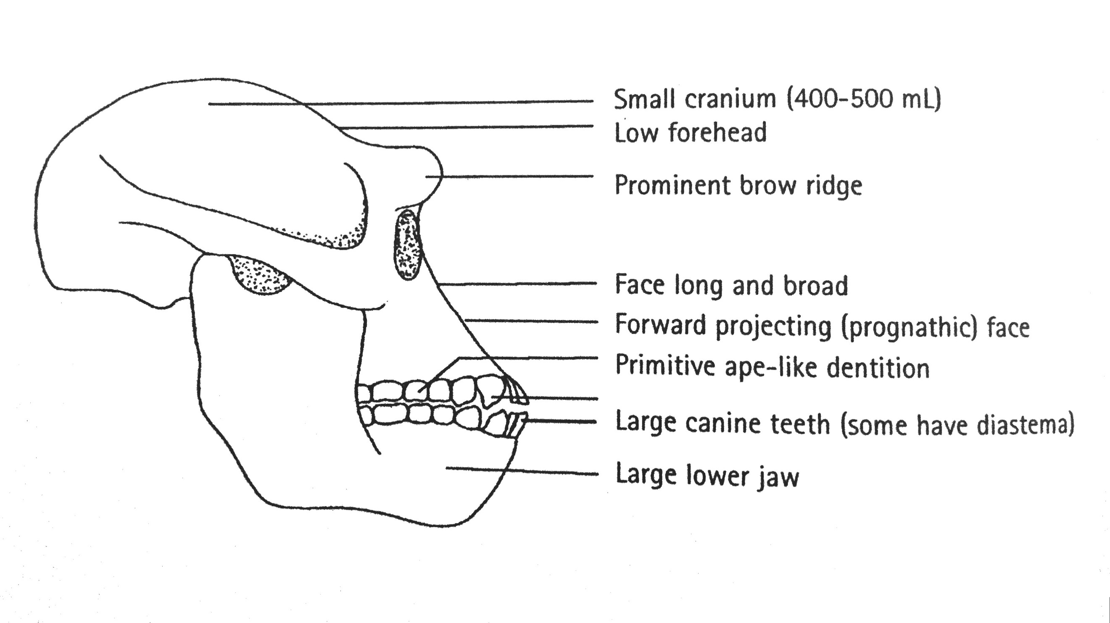

Australopithecus Africanus
Geographical Location: Southern Africa
Time period: 3.3 to 2.5 million years
Cranial capacity: Average 430cm³ (small)
Height: 1.1-1.4m (Short)
Weight: 30-55 Kg (Light)
Skull/Jaw: Small cranial capacity, Reduced brow ridges, low forehead, flared zygomatic arch.
Jaw: Prognathic jaw, smaller canines, slightly more modern teeth (smaller).
Locomotion: Bipedal: central foramen magnum, all post cranial adaptations to bipedalism (spine, pelvis, femur, knee, foot)
Culture: Not required

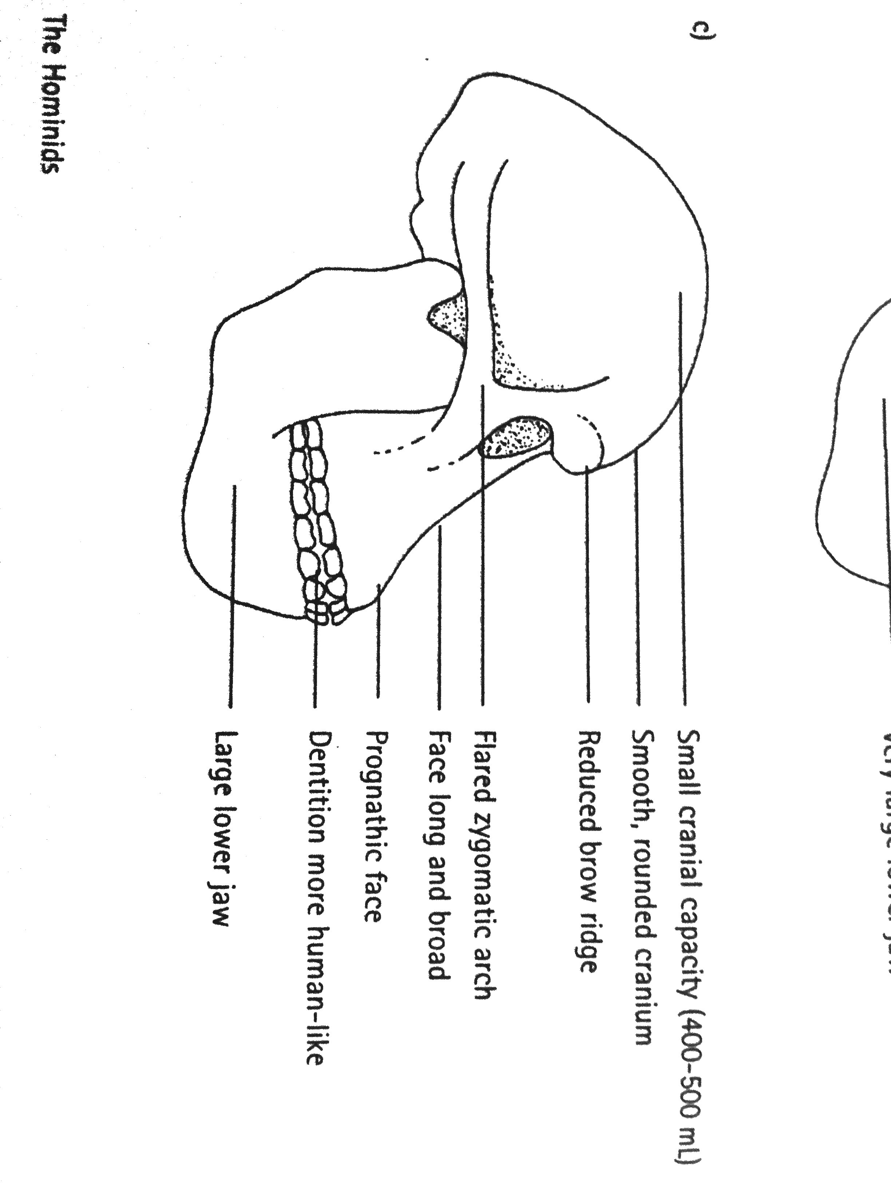
Paranthropus robustus
Geographical Location: Southern & East Africa
Time period: 2.3 to 1 million years
Cranial capacity: av 520cm³ (small)
Height: 1.1-1.4m (Short)
Weight: 40-80 Kg (Heavier)
Skull/Jaw: Very robust, Sagittal crest, flared zygomatic arch, low forehead, brow ridges
Jaw: Massive jaw, Prognathic, Smaller canines, large molars.
Locomotion: Bipedal: central foramen magnum, al post cranial adaptations to bipedalism ( spine, pelvis, femur, knee, foot)
Culture: Not required

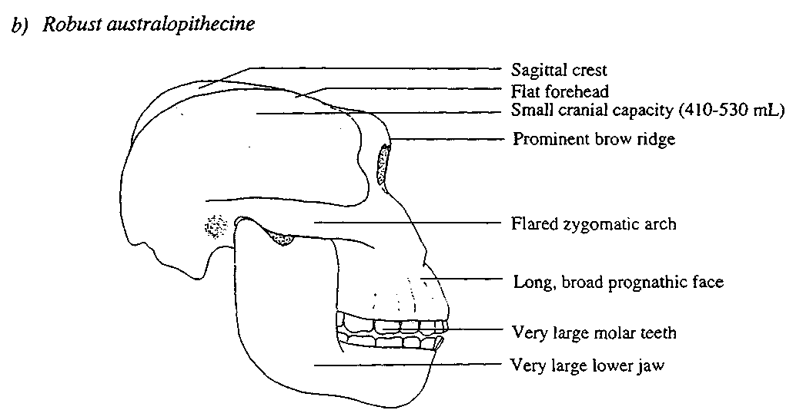

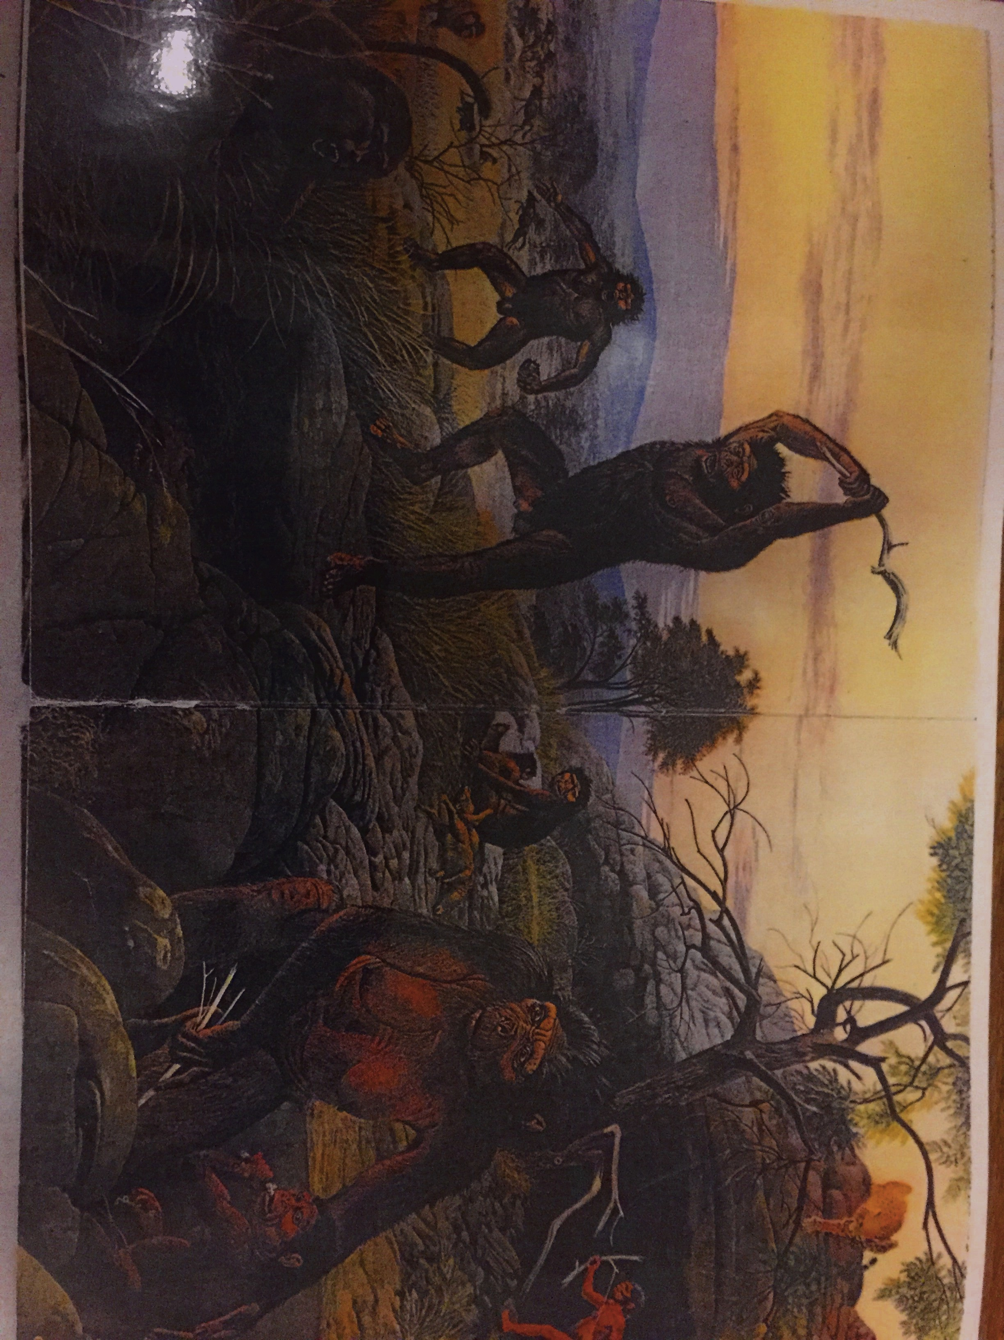

Homo habilis
Alternative Name: Handy man
Geographical location: Southern and East Africa
Time period: 2.3-1.8 million years
Cranial capacity: 600cm³ to 800cm³ (average 700cm³)
Height: Average -157cm(m) 125cm(F)
Weight: Average -52kg(m) 32kg(F)
Skull/Jaw: Larger brain, smaller jaw, smaller teeh and flatter face than Australopithecines. Still prognathic with brow ridges compared to sapiens
Culture: Made and used simple stone tools (Oldowan) with primary flakes
Used tools as cutters and scrapers
Some possible hunting, mainly scavengers
Diet: Omnivores, increased meat and marrow in diet (key difference) (Meat + fats required for larger brain)
Other: Large family groups had food sharing and division of labour. Temporary shelters. Daytime gathering food night time in trees. Robust hands. Enlarged speech area of brain (Broca’s) – Therefore simple sounds/speech.

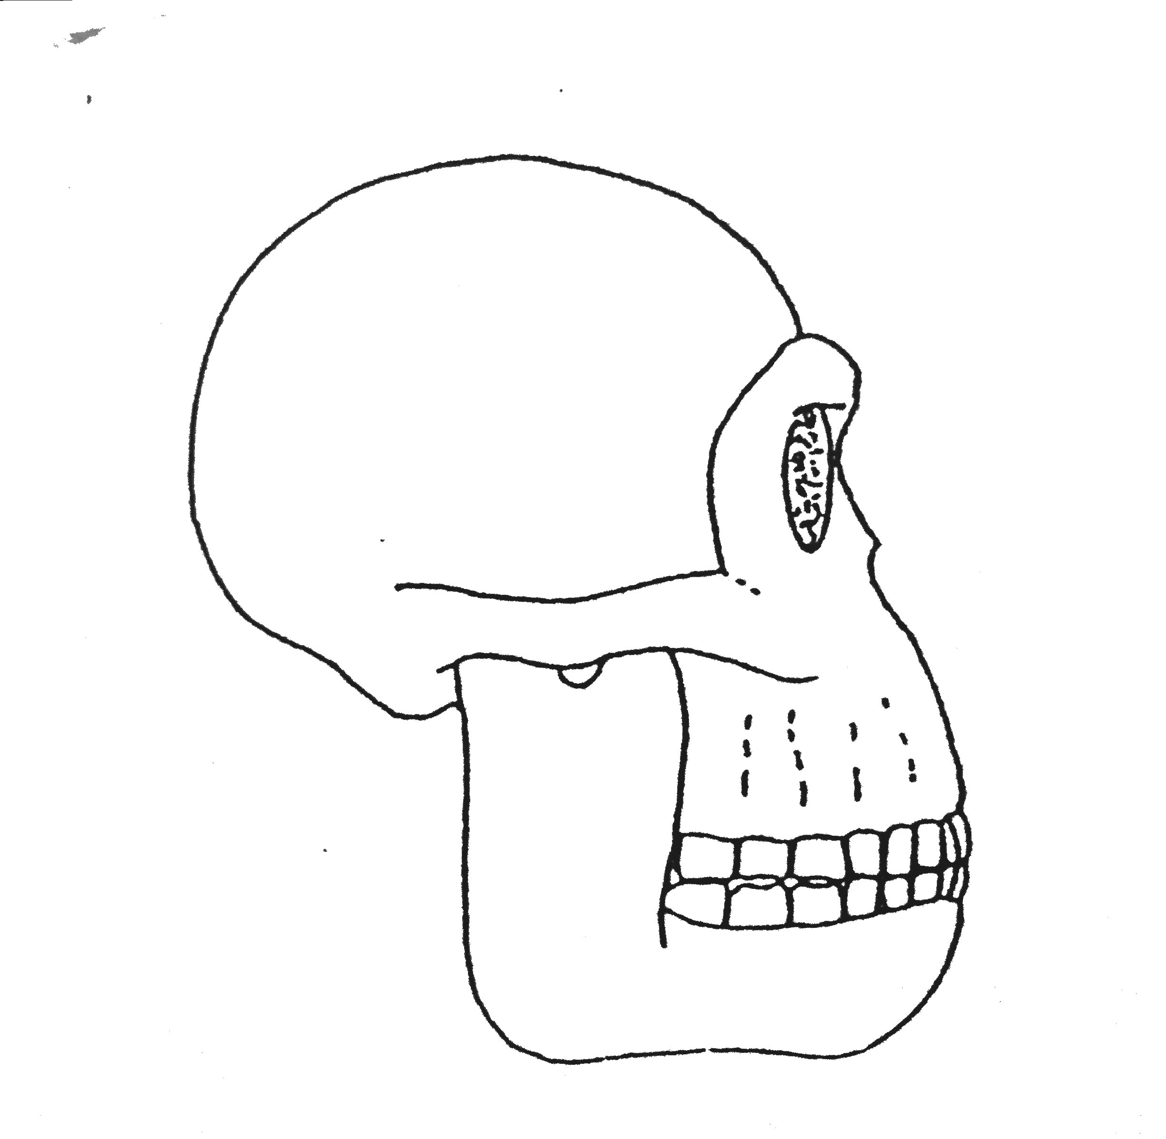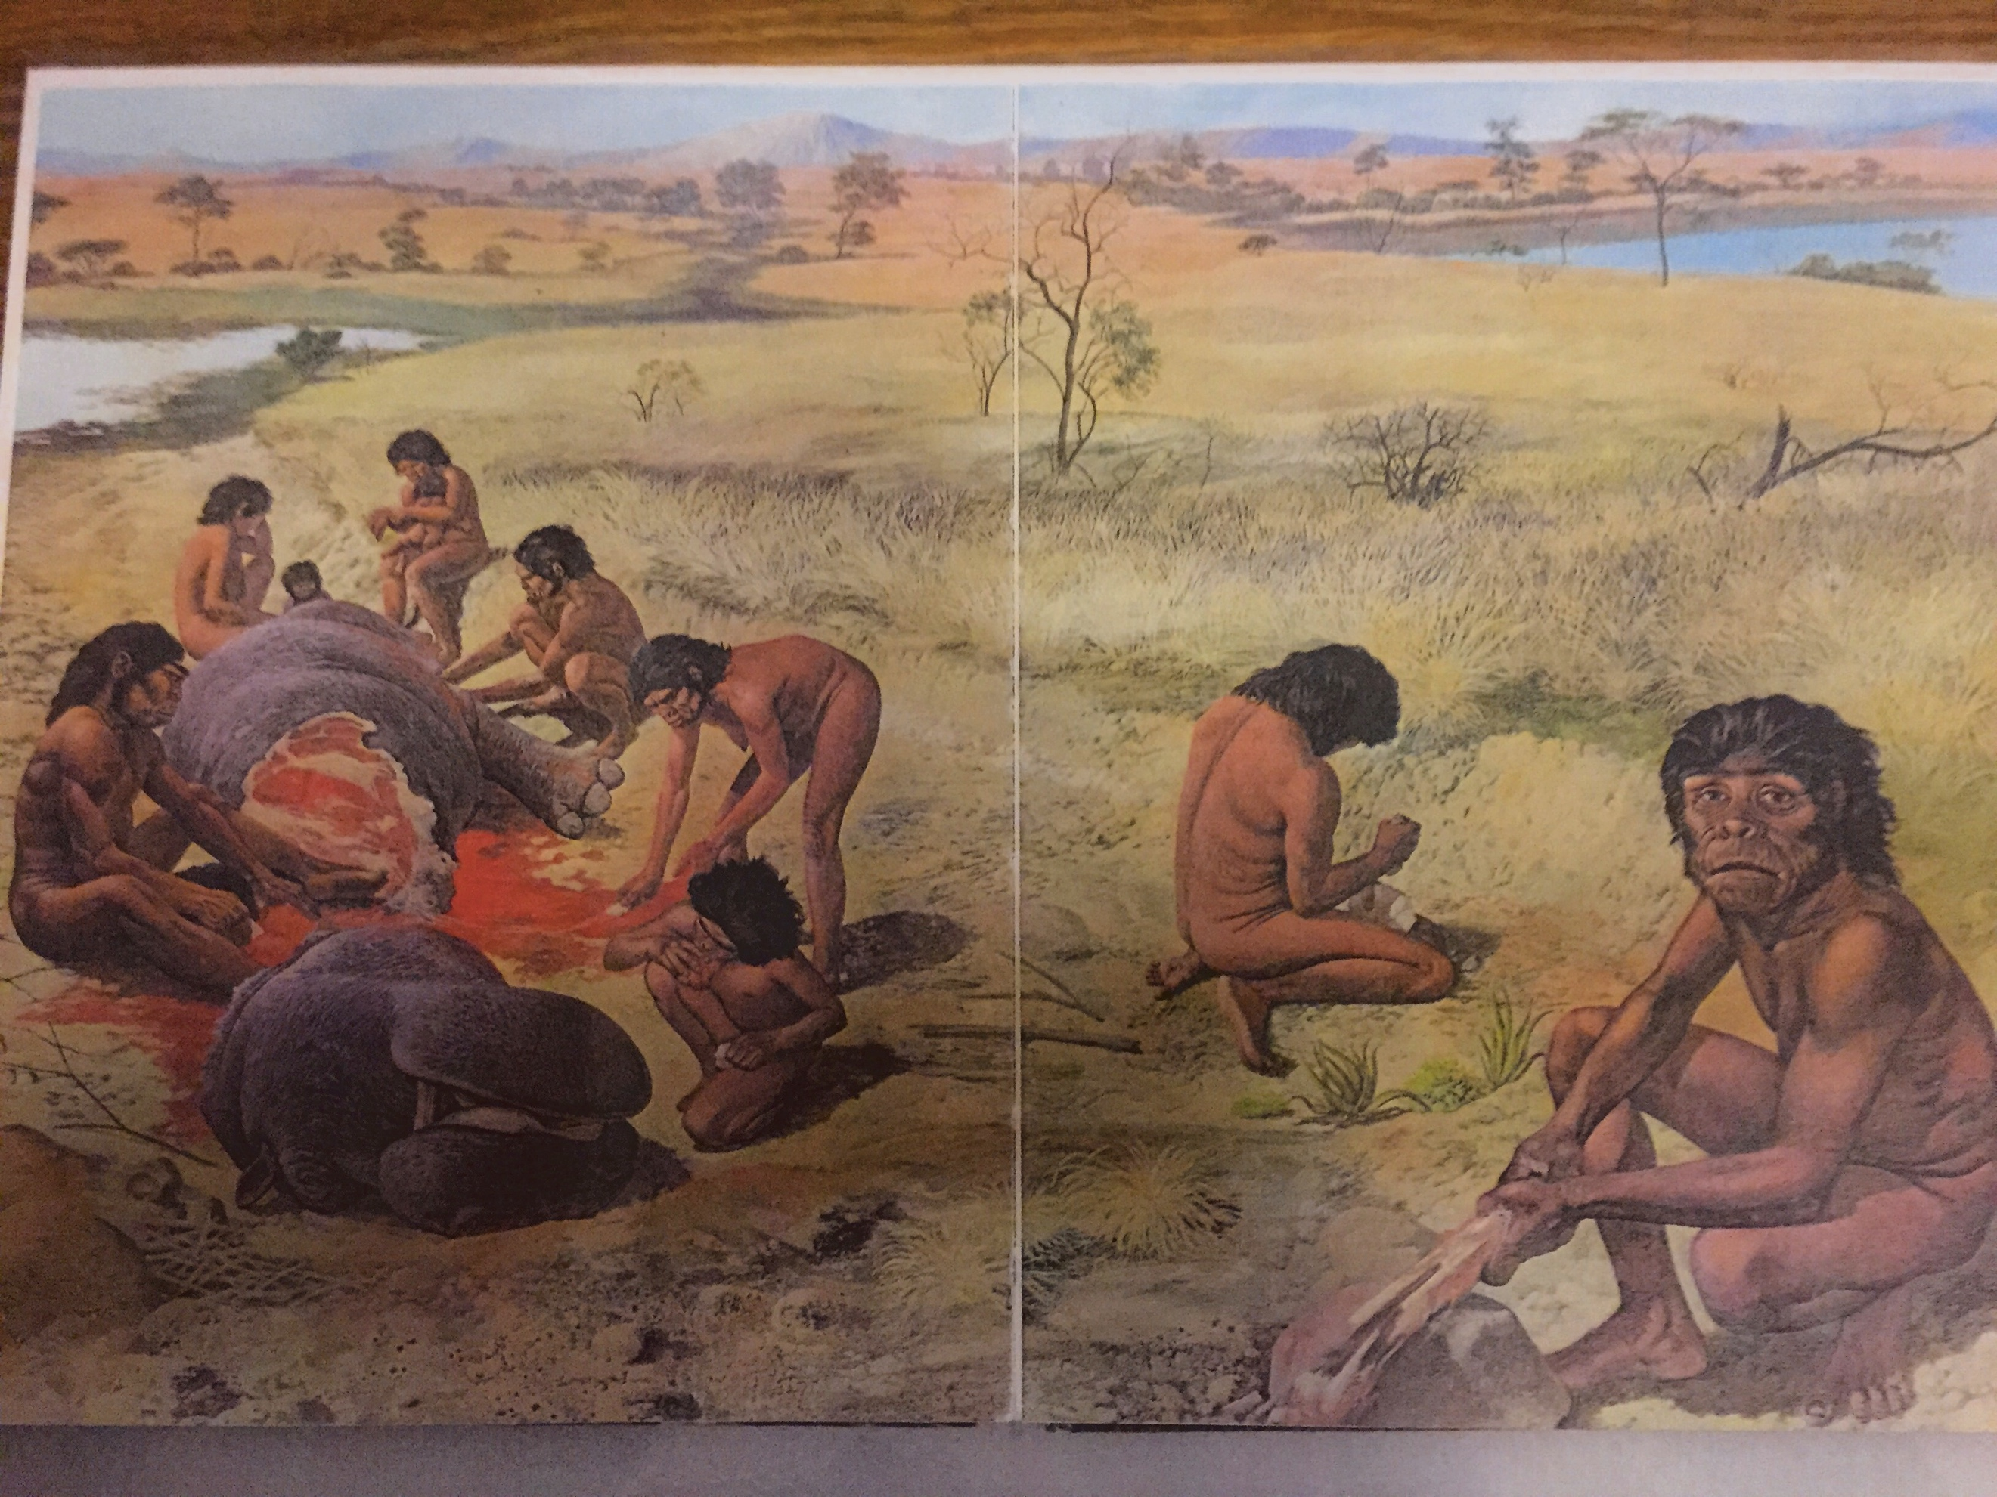

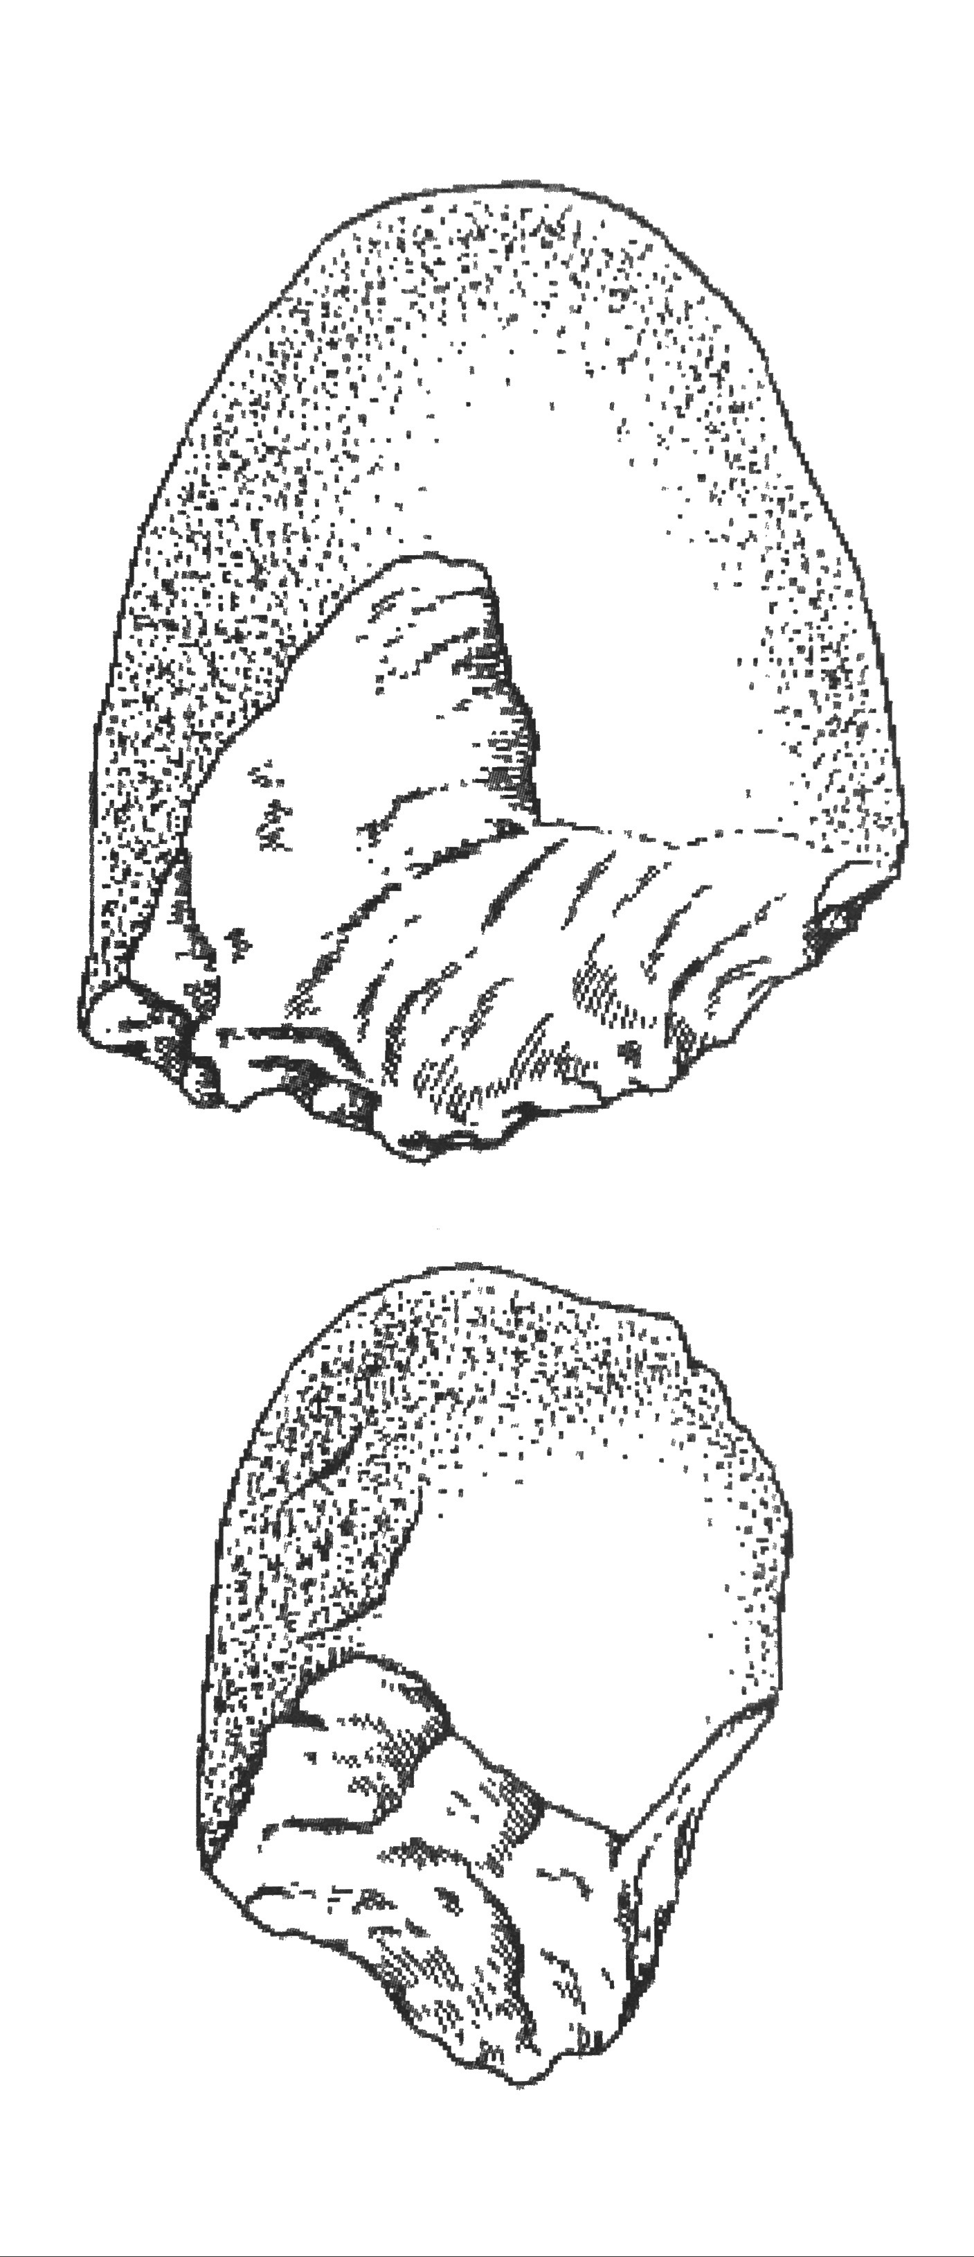

Homo erectus
Alternative name: Java man, Peking man, upright man
Geographical location: Africa – Europe – Asia (thought to be first to move out of Africa)
Time period: 1.8 million-50 000 years
Cranial capacity: 850cm³ to 1150cm³ (average 1000cm³)
Height: Average -180cm
Weight: Average -54kg
Skull/Jaw: Heavy brow ridges, thick skull, low flat forehead, heavy chinless jaw, prognathic upper jaw, smaller more modern teeth, occipital bun, central foramen magnum.
Larger brain
Less prognathic than habilis
Larger Brocas area (speech)
Culture: First to use fire for cooking (more nutrition, kills parasites), warmth, protection and light, allowed migration. Made and used more complex pebble (stone) tools with (secondary flaking) hand axes (Acheulian)
Cooperative hunting for larger animals (tools found with bones at butchers sites)which suggests complex language for communication (Boca's area) Division of labour (woman gathered nuts, fruits, roots and berries and men did the hunting
Constructed living seasonal sites and lived in caves increased use of home bases
Modification of environment to suit own purposes.
Diet: Omnivores
Other: Possible cannibalism, Robust post cranial skeleton, less body hair, possible migration due to population pressure.
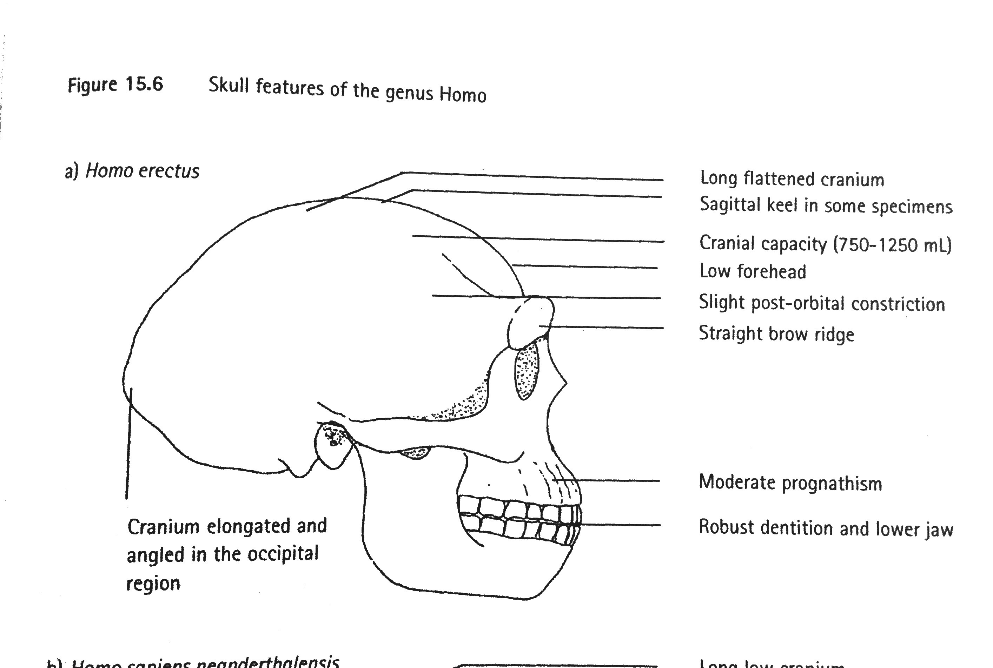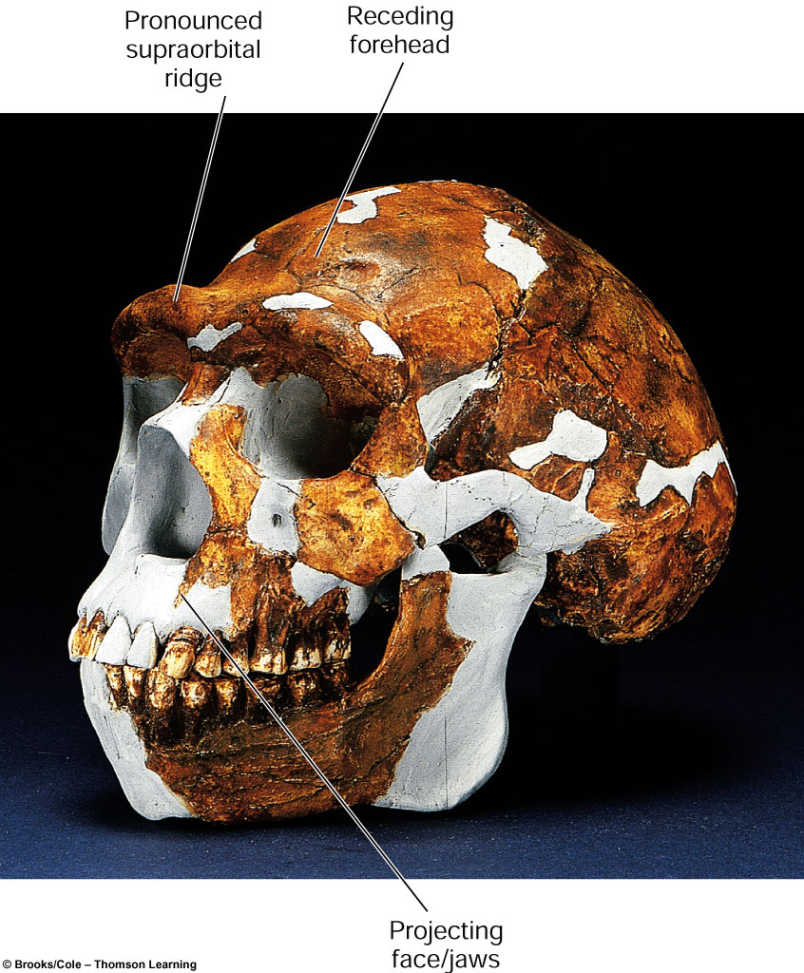

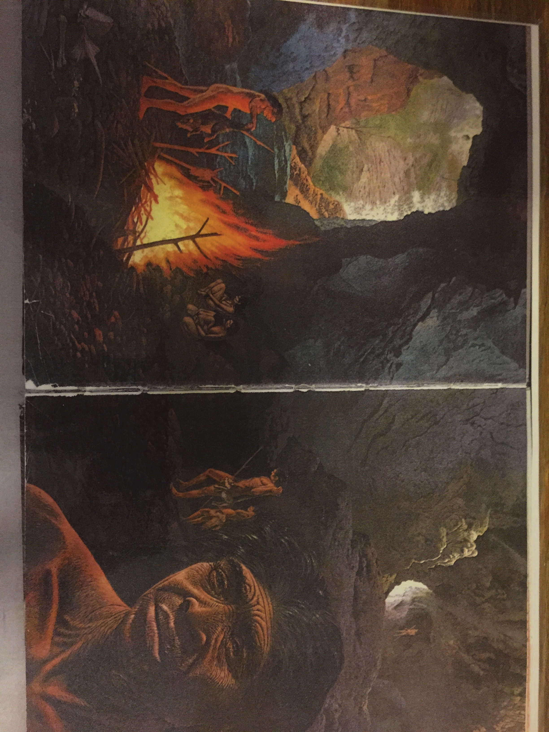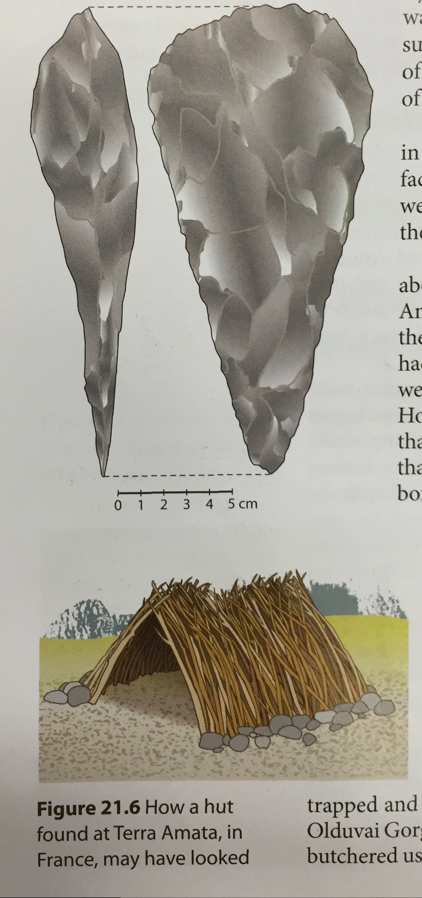

Homo neanderthalensis
Alternative name: Neanderthal man
Geographical location: Europe and middle east
Time period: 200 000 to 30 000 years
Cranial capacity: 1500cm³ (average)
Height: 150cm
Weight 70Kg
Skull/Jaw: Long low cranium, sloping forehead, reduced brow ridges and large occipital bun, no chin, large nose, modern teeth, slight prognathism.
Culture:
Complex pebble (stone) tools with tertiary flaking, wood and stone tools combined (spears). Mousterian too culture.
Cooperative hunting of large game (mammoths/bison) with butchering and transfer of meat.
Complex language
Division of labour
Wore simple clothing (animal skins) for protection against cold.
Increased reliance on home base and fire for warmth, cooking, light and protection
Abstract thinkers
Evidence of religious rituals with burials of dead (bear cult)
Care of sick and disabled
Possible cannibalism
Diet: Omnivore
Other: Large nose moistened and heated cold air (adaptations to cold)
Very stocky – very heavily built. Muscular, Short limbs, barrel chested. Adaptations to the cold.

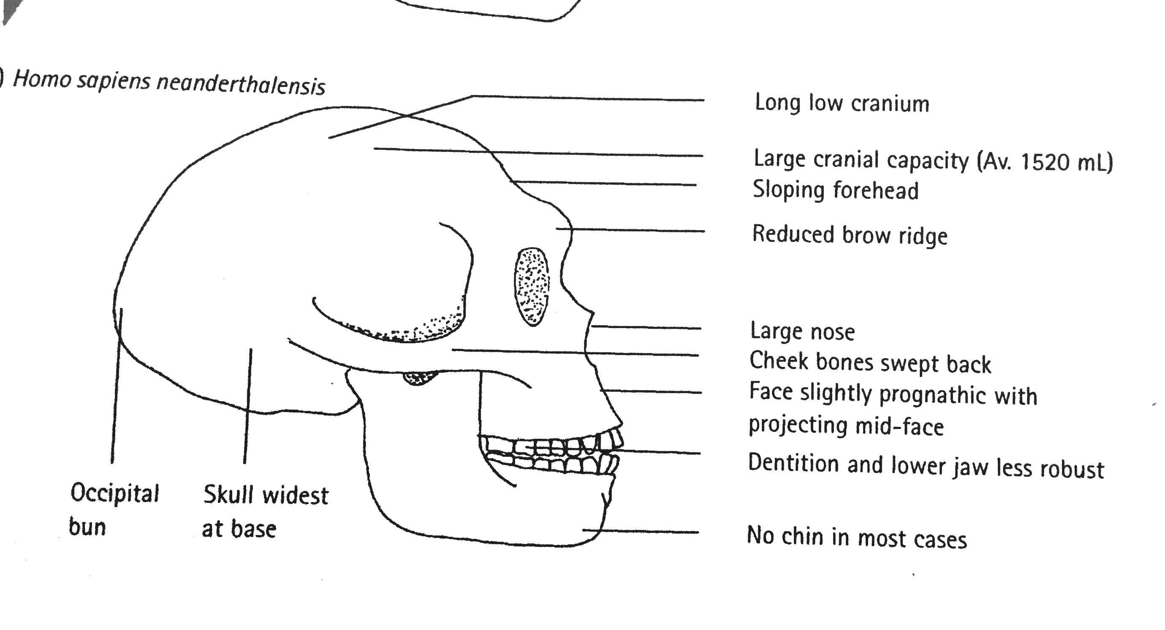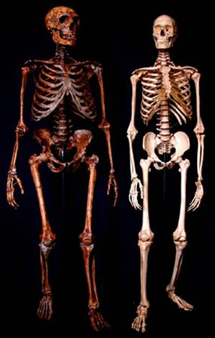

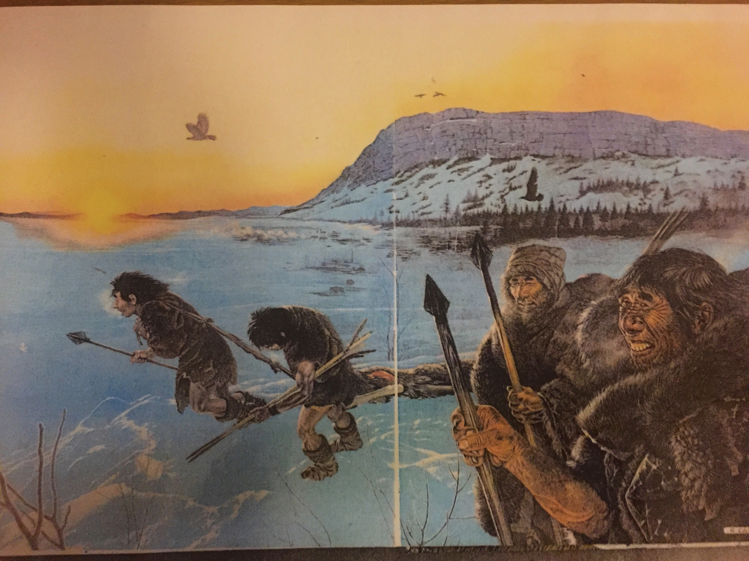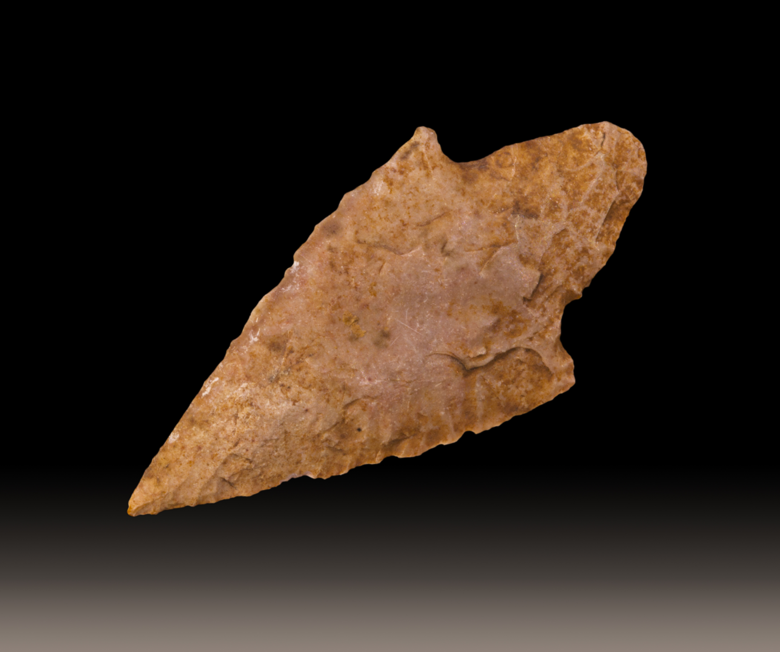

Homo sapiens
Alternative name: Humans
Geographical location: World wide
Time period: 100 000 years – present
Cranial capacity: 1350 average
Height : 180cm
Weight: 80Kg
Skull/Jaw: Chin, high vertical fore head, slight brow ridges, unspecialized small teeth, small jaw, rounded, smooth cranium, same as our skull. Lightweight. Flatter face.
Culture:
Build more complex permanent shelters
More elaborate clothing (sewing)
More advanced, complex tools including use of bone, horn, and ivory to make needles, hooks and harpoons (hafting combination of wooden and stone tools)
Visual art cave paintings, bone carvings and clay statues. Jewellery
Fishing with nets
Belief in life after dead
Other: Taller and slightly more built than neanderthals.

